**Issue Discussion Topic Workshop: Disruptive and Predatory Behavior**

**Session Materials:**

* Note sheets with discussion questions
* Examples and solutions session handout
* Brainstorming/Groundrules
* Facilitators’ Instructions/Vision for NA Service

**[Instructions for facilitators are contained in these brackets]**

**Welcome and Introduction 2 minutes**

**Welcome**

Welcome everyone and introduce presenter(s)

**Introduction**

Slide: local resource and SPs page

Disruptive and predatory behavior is not a new topic in NA. A 2007 service pamphlet addresses “Disruptive & Violent Behavior” ([www.na.org/sps](http://www.na.org/sps)), and World Services has been collecting and posting resources sent in from service bodies for a few years ([www.na.org/localresources](http://www.na.org/localresources)). With meetings moving to a virtual platform during the pandemic, some predatory and disruptive behaviors seemed to increase, and some new ones emerged.

Slide: *CAR* survey results

Guided by Fellowship input and response to the *CAR* survey, the 2023 World Service Conference selected this as an Issue Discussion Topic, or IDT.

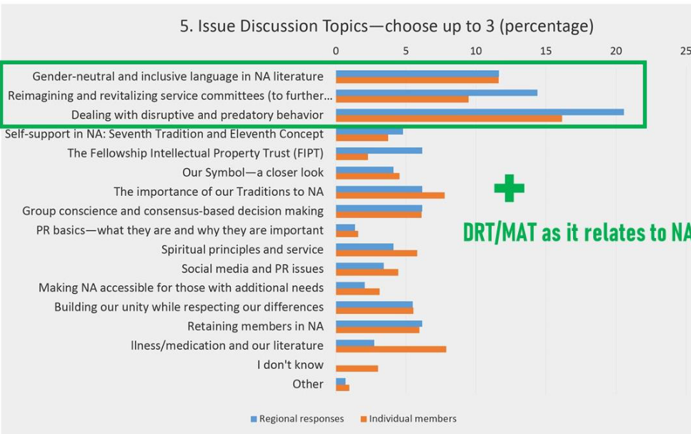

Slide: This topic, at its heart

This topic, at its heart, is about our ability as a Fellowship to carry the message—if new members do not feel safe, they won’t stay. It’s also about public relations— if professionals hear negative things about NA, they will stop referring clients to us, treatment centers will go somewhere else, and addicts who need us may never find us.

Slide: *Living Clean* quote

As *Living Clean* says, “All our lives we had looked for the peace and safety we experience in recovery.” Addressing predatory and disruptive behavior is part of how we give it away.

**Large-group Discussion: Atmosphere of Recovery 30 minutes**

Slide: Atmosphere of Recovery

Let’s start by talking about the atmosphere of recovery when we get together. Whether at an in-person or virtual recovery meeting, when we are doing service, or when we are fellowshipping, an atmosphere of recovery is about making sure everyone who needs NA feels safe and welcome.

One of the local resource workshops characterizes an atmosphere of recovery as one of anonymity, sharing, listening, respect, no judgment, and safety.

* **What else characterizes an atmosphere of recovery?**

*[Facilitator: call on members rapidly and have them answer quickly.]*

Slide: Ideas to increase the atmosphere of recovery

Atmosphere of Recovery was an Issue Discussion Topic for four years. Members shared about what groups and members can do to increase the atmosphere of recovery. Some of the ideas that came up repeatedly included leading by example, welcoming and paying attention to newcomers, creating a safe meeting environment, sharing in a way that other members can identify with, mentoring trusted servants, and group unity.

* **What else contributes to an atmosphere of recovery? How do I contribute?**

Some of the challenges to the atmosphere of recovery that came up repeatedly during these past discussions included the negative actions of a few members undermining the group’s atmosphere, not enough trusted servants who understand the importance of their role, prejudice, and a lack of mutual respect.

**Negative Behaviors**

Slide: Negative Behaviors—we need to come to a common understanding

This next part can be difficult to talk about, but we need to come to a common understanding of the problem before we can seek a solution.

Many things can fall into the category of disruptive or predatory behavior. One way to think about disruptive behavior generally is behavior that interferes with the peace, security, and integrity of a meeting and its members. Disruptive behavior can range from yelling “clean” after someone says “sober” in a share, to brandishing a weapon during a meeting. It’s a wide range.

Slide: Negative Behaviors—predatory behavior

Predatory behavior happens when a member knowingly or unknowingly takes advantage of another member's vulnerability. New or returning members may be especially vulnerable to predation. Sometimes the behavior is blatant, sometimes subtle, but it is often characterized by manipulation. It could include financially motivated manipulation, bullying, racism, or homophobia.

Some predatory behavior has a sexual connotation or targets sexuality. It could include unwanted gestures, words, attitudes, or actions, whether virtual or in-person. And it’s not limited in terms of age, gender, culture, and sexual orientation.

Predatory behaviors push boundaries. People may be defensive and play the victim when called out. Sometimes the person is unaware of what they are doing and other times they know exactly how they are responsible.

Slide: Examples of predatory behavior

Here are some examples of disruptive and predatory behaviors:

* Bullying/picking on/harassing
* Threatening physical violence
* Racist words or actions
* Homophobic words or actions
* Theft
* Asking members for money
* Private messaging members (virtual)
* Distribution of non-approved literature
* Stalking
* Violating restraining orders
* Using a phone to record during meeting
* Loud family members/pets (virtual)
* Disruptive children (in-person)
* Interrupting when member sharing
* Making unwanted sexual advances

Slide: What are some other examples?

Part of what makes this difficult to talk about is that we want to believe there is a bright line, but it’s really a continuum. Sometimes members may have good intentions, but their actions have negative results.

Sometimes actions that make some members very uncomfortable don’t seem challenging to others.

*[Facilitator: make a list using either the list included, the examples offered from the Large Group, or a combination of both. You can use a big post-it at the front of the room, or a document on a shared screen. This list will be used in the small group discussions.]*

* **What are some other examples?**

**Positive Solutions**

Slide: Positive Solutions: We should be clear…

For the rest of this workshop, we are going to talk about solutions.

We should be clear to all addicts: You are welcome. Behavior that harms others or disrupts the atmosphere of recovery is not welcome. Every addict has a right to be a member, but how do we make sure everyone feels safe?

A group that is healthy has a good “spiritual immune system,” and it can work to protect its members from these negative behaviors.

Slide: *Group Booklet* quote

*The Group Booklet* reminds us “Common sense, open minds, calm discussion, accurate information, mutual respect, and healthy personal recovery enable a group to deal effectively with almost anything that comes its way.”

As group members, part of our responsibility is to make sure that those most vulnerable to predation are being talked to by members who are not.

Many of us arrive to NA with a history of trauma or abuse. We can’t blame others for not knowing their actions may not be acceptable, but we also don’t want to reinforce that trauma or damage. When we don’t nurture our most vulnerable members, we can leave an opening for them to be preyed upon. It’s a collective and individual responsibility.

Slide: Positive Solutions: The worst thing we can do.…

The worst thing we can do for a newcomer is make NA feel like where they came from. We need to do our best to protect our members, while respecting their right to make their own decisions. The Basic Text cautions that “the temptation to give advice is great, but when we do so, we lose the respect of newcomers” (Step Twelve). It can be a fine line between being protective and overbearing.

Also from the Basic Text, “Although addicts are basically the same in kind, we do, as individuals, differ in degrees of sickness and rates of recovery.” (Recovery and Relapse) You might ask yourself if you are the right person to offer help to a particular newcomer.

This is not about policing our rooms or members. We all have a right to recover. “The only requirement for membership is a desire to stop using.” NA membership is not revocable. We may not always know exactly what to do, but we must try. This is about giving each other space to recover.

Slide: Disruptions in virtual meetings

Disruptions in virtual meetings present particular challenges. The easiest solution might seem to be to eject a person or people from an online meeting, but not all disruptive behavior online is the result of “Zoom bombers.” Sometimes an attendee’s bad behavior might be a sign that they really need a meeting! We want NA meetings in person and online to be safe and welcoming to all – even when someone is challenging our patience. There are steps we can take to protect the meeting: hosts may limit some functions, such as mute or turn off a camera, restrict screen sharing, or close down the chat feature. There are tools and suggestions in [*Virtual Meeting Basics*](https://na.org/wp-content/uploads/2024/12/Virtual-Meeting-Basics_2024-12-04.pdf)*.*

Slide: possible solutions

On the screen is a list of possible solutions that have been suggested by members. This is by no means complete! The answers that work tend to be spiritual in nature. When we think about applying principles rather than enforcing rules, we’re on the right track.

**This list can be distributed in virtual meetings via the chat feature in Zoom.**

Solutions

* Add a paragraph to the group format.
* Approach new members and make sure they feel welcome.
* Join up with another member or members and pull aside the member exhibiting the behavior and try to talk to them.
* If someone is violating a protective order, have a couple of people offer to go to another meeting with them.
* Turn off camera/put a member in the waiting room (virtual).
* Discuss behavior in a group business meeting.
* Chairperson/leader/group secretary can request a short break or ask group to join in a prayer or moment of silence.
* Hold a recovery meeting focused on a discussion about atmosphere of recovery.
* Discuss with other groups at a local service body meeting.
* Approach member in a loving and caring way.
* Temporarily suspend meeting.
* Call law enforcement.

Listing solutions or tools is not the same as applying them. Now we’re going to have small group discussions about how we might address specific scenarios.

**Small-group Discussion 40 minutes**

Slide: Small group discussion

We’re going to spend some time discussing healthy ways to respond to some of the examples of negative behavior we listed.

*[Facilitator: If there are enough people at the workshop, split the room into smaller groups or breakout rooms so that everyone gets a chance to share. You can prioritize the negative behaviors list either with dots or raised hands. Or each small group/breakout room can just pick a behavior to discuss.]*

These kinds of small-group discussions can be more inclusive and give us an opportunity to drill down and think about how to put our principles into practice. Use the list of solutions if it’s helpful in your discussion, but don’t be limited by it.

This is only a 90-minute workshop, and we can’t possibly discuss all of the possible examples. The most important part of the conversation today is about how to feel empowered as individuals and a group to put the principles into practice in difficult situations.

*Select a facilitator and a recorder for the discussion if in a small group and make sure everyone gets a chance to share. The group should also choose someone to report back to the large group after the discussion.*

Questions for small groups:

* **The example we are discussing is _____________________**
* **What is our responsibility as members?**
* **What is our responsibility as groups and service bodies?**
* **Given that, how do we address the behavior? How do we ground our approach in spiritual principles?**

**Reporting Back, Concluding Discussion, and Closing 18 minutes**

**Reporting Back**

*If the room broke into small groups, come back together for the concluding discussion.*

Slide: Let’s hear back

Let’s hear back from your discussions. Tell us what example(s) you discussed and some of the solutions you talked about in your group.

Thanks everyone. We often don’t feel empowered to address unhealthy and predatory behavior in NA, but when we don’t, we may send a message that this type of behavior is okay or condoned by our group. We can restore our group to sanity.

**Concluding discussion**

Before we go, we want to ask everyone about resources that might help:

*[Facilitator: hear from a few as time allows. If there is no time for this, try to schedule some later time to talk about local tools and encourage members to fill out the input form on* [*http://www.na.org/survey*](http://www.na.org/survey)*]*

Slide: Are there tools?...

* **Are there tools you can create locally that will help?**
* **What kind of resources would be useful for NAWS to create?**
* **If NAWS were to create or update a resource or resources, what would you want it to include/say?**

Slide: Don’t forget…

Please, please share your ideas about the topic and resources to address it by filling out the form on [www.na.org/survey](http://www.na.org/survey).

Also, World Service asks that you please send any local resources to [wb@na.org](mailto:wb@na.org) to post on [www.na.org/localresources](http://www.na.org/localresources).