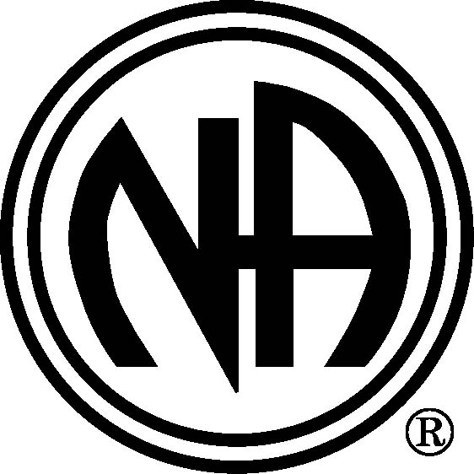
Member Name
Member Address
Member phone number

Vancouver Area Service Committee of Narcotics Anonymous
P.O. Box 1695, Station A
Vancouver, BC
V6C 2P7

Date

RE: RESTITUTION AGREEMENT FOR THEFT OF VANCOUVER AREA SERVICE COMMITTEE OF NARCOTICS ANONYMOUS FUNDS

Dear ;

On behalf of the Vancouver Area Service Committee of Narcotics Anonymous (“VASCNA”), I write regarding your admitted theft of VASCNA funds. While we are grateful for your admission of the theft of VASCNA funds prior to our determining it through an audit process, and while we wish you no personal harm as a result of guilt, shame or financial hardship, VASCNA does require your guarantee that you will make complete restitution. VASCNA also requires you to resign from your current elected service position of ______________.

In accordance with the VASCNA Policy and Procedures Manual, which adopted N.A. World Service Bulletin #30: The Theft of NA Funds (AMENDED), into policy in July 2003, we have formulated the enclosed agreement for the repayment of funds that you have admitted absconding from VASCNA during the time you held the elected position of VASCNA Treasurer.

As you are likely aware, some NA members may be angry and hurt as a result of this incident, but we are hopeful that we can resolve this matter through a process that is both responsible and spiritual. As NA members practicing spiritual principles, we will endeavor to support you in continuing your recovery, utilizing meetings, your sponsor, and the Twelve Steps throughout this process.

Please contact me at (604) 320-0120 by _________, to discuss this matter.

Yours truly,

Jeff Lamb
VASCNA Chairperson
Enc.

