GOLD COAST AREA OF NARCOTICS ANONYMOUS AREA SERVICE COMMITTEE
“NEW GSR SURVIVAL GUIDE”

Congratulations on being elected to represent your Gold Coast of Narcotics Anonymous Home Group as their GSR (Group Service Representative) or alternate! You were nominated and elected to this service position within the Gold Coast Area by your group, and are a critical and vital link that connects your group to the area. We have written this document to provide you with a “How-to” guide to help you navigate through the tasks of representing your group. There are a few moving parts that you will need to become familiar with in order to fully appreciate the importance of the critical elements that keep information flowing between the groups, the Area Service Committee, the Regional Service Committee and beyond.

Getting Started
Introduce yourself!

A few things to do in order to let us know who you are, and what Gold Coast Area group you will be representing in the Area Service Committee ( “ASC”) meeting. As you are the interface between your home group and the ASC, it is important to know who you are! Please email the following to the Gold Coast ASC Secretary (secretary@goldcoastna.org), and the Gold Coast Public Relation (‘PR”) subcommittee (public-relations@goldcoastna.org):
  - Your name, or how you would like to be referred to, and who you are (GSR/GSR alternate)
  - The group you represent
  - Your contact phone number
  - Your email
If there are both a GSR and a GSR alternate elected to represent your group, please make sure that the contact information for both are sent to both the Gold Coast ASC Secretary and Gold Coast Public Relations. When you complete your term as GSR for your group, please notify both the ASC Secretary and Public Relations of the change. The same applies if you are moving from GSR alternate to GSR. We just want to keep the lines of communication open and know who to contact for important Gold Coast Area information.

Meeting Information
If you have information regarding a home group meeting cancellation or if your home group will be moving, or closing, please make sure to contact Public Relations (public-relations@goldcoastna.org) as soon as possible so that the information can be posted.

Attending the Monthly ASC Meeting

The ASC meets on the second Sunday of each month at 1:00 P.M. on Zoom. There may be occasions where the monthly ASC meeting may coincide with a holiday. In the event there is a calendar conflict with the monthly ASC, that issue will be addressed at the ASC meeting(s) prior to the date in question. To stay informed about Area events, including the link and schedule for upcoming ASC meetings, it is useful to subscribe to receive text reminders. If you would like to receive text reminders, please TEXT gold coast asc (with spaces) to 855 - 918 - 3505. The text subscription information can also be found on the first page of each monthly ASC meeting report.
If you are a new GSR or GSR alternate, you will need to attend the “New GSR” Orientation which is held each time the ASC meets, starting at 12:30 P.M.

When you log into Zoom, please format your screen name as follows:
(GSR) homegroup name.

STRUCTURE OF THE ASC MEETING
TABLE ASC-01: ASC MEETING FORMAT ( GOLD COAST POLICY MANUAL ASC-28)
1. Open meeting with the Serenity Prayer.
2. Read Traditions, Concepts, Definition of an ASC, GSR and GSR Alternate qualifications and responsibilities (Vice-Chairman).
3. Open Forum.
4. Roll Call by Secretary to include Administrative Committee, Subcommittee Chairpersons, RCM, RCM Alternate, GSRs or their Alternate in their absence (to be done in alphabetical order by group). Ask for new groups after roll call.
5. Group reports (to be done during roll call).
6. Establish quorum (for the purpose of conducting business).
7. Move to accept last month's minutes.
8. Old business.
9. Elections and nominations.
10. RCM report.
11. Subcommittee reports in alphabetical order.
12. Re-establish quorum for voting purposes.
13. New Business (Prearranged agenda has priority).
14. Treasurer's report and motion to accept the Treasurer's report.
15. Review the business of the day (Secretary) (a written review is presented in table format within the ASC meeting minutes report and the location is cited in the bullet point).
16. Establish the next meeting time and place.
17. Meeting closes with the Third Step Prayer.

REPRESENTATION & VOICE
1. All ASC meetings are open to NA members. Any member may attend the ASC and the voice of the individual member may be heard on the floor during Open Forum.
2. Only those listed below can make, second, or amend motions:
a. GSRs or their Alternate in their absence.
b. RCM or Alternate RCM in their absence.
c. Subcommittee Chairpersons or their Vice-Chairpersons in their absence.
d. Members of the Administrative Committee or their assistants (i.e. the Assistant Treasurer
and the Assistant Secretary in the absence of the Treasurer or Secretary).
3. To be recognized on the floor, a raise of the hand is necessary.
4. A GSR may only represent 1 group at a time.
5. No proxy representatives.
6. The Gold Coast Area joined the South Florida Region following the February, 1990 ASC.
7. Subcommittee reports should include whether the Chairperson and/ or Vice-Chairperson attended the RSC.
8. A Conference Agenda Report Workshop will be held annually the weekend following the Regional workshop on the Conference Agenda Report and following the availability of this report to the groups.

QUORUM & ACTIVE ROSTER
1. Official quorum to conduct business is one more than half of the groups appearing on the roster at the time of roll call. GOLD COAST POLICY MANUAL ASC-23
2. Official quorum for voting purposes is 2/3 or majority of the voting participation. Voting participation is defined as the total number of GSRs or ALT GSRs that are voting on a given motion. (EXAMPLE: If only 20 of the 26 groups present vote on a given motion, the count of the vote would be based on the 20 people actually voting. In this case, 14 would be 2/3 and 11 would be the majority).
3. A simple majority of groups on the roster is required to open the ASC as well as conduct New Business after the 2nd roll call, and a simple majority of established quorum (to conduct business) is required to vote on a motion. (EXAMPLE: If the established quorum to do business is 26, at least 14 groups must vote on the motion).
4. Official quorum to conduct business must be reached by thirty (30) minutes after scheduled starting time.
5. Only duly elected Alternates are eligible for quorum in the GSR's absence. Establish a new quorum when the roll call is taken that most nearly precedes that start of New Business.
6. A quorum call from the floor is always in order.
7. If any group is not represented at two (2) consecutive meetings, they are dropped from roll call. (The purpose of this is to establish an accurate quorum).

ACCESSING THE ASC MINUTES AND SUPPORT DOCUMENTS
Receipt by Subscription
Each month, the minutes from the monthly meeting of the Gold Coast Area Service Committee herein referred to as “ASC”, can be received by email. To receive the minutes by email, you should set up a personal account on the Gold Coast of Narcotics Anonymous website (www.goldcoastna.org) . To set up a personal account, take the following steps :

- In the search query window of your web browser, input www.goldcoastna.org and you will be brought to the Gold Coast Area of Narcotics Anonymous home page which should look like:

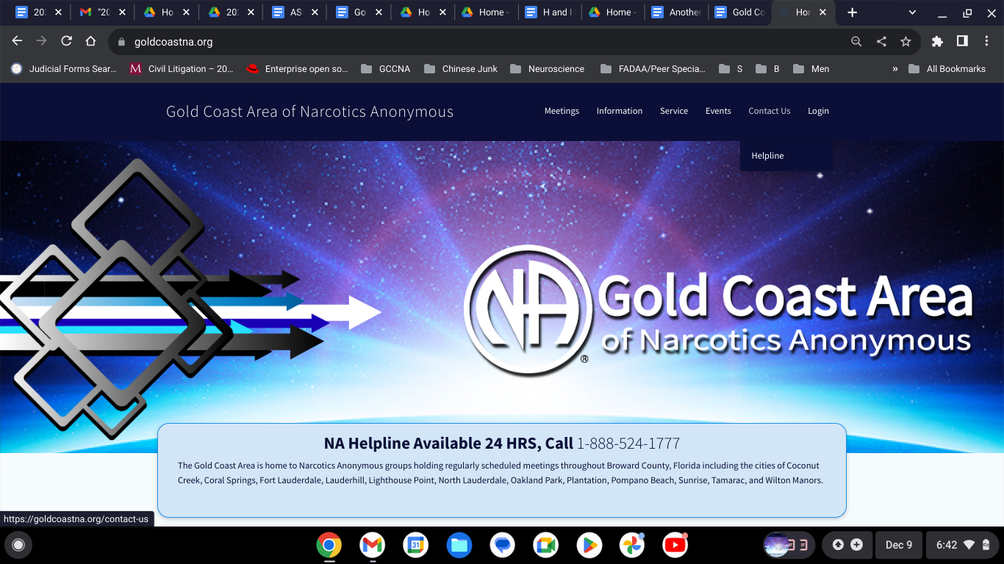

- On the homepage of the website, go to the “Service” tab in the upper right-hand corner of the 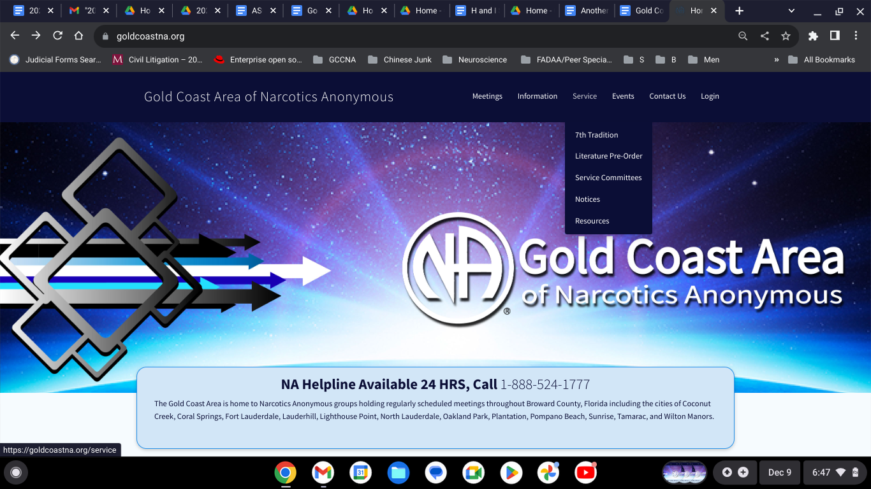screen and click on “Resources” which is the last option on the drop-down menu.
- On the left hand side of the “Resources” page, you will see a field with the “Newsletters” caption. In that field, there are three radio buttons corresponding to three different subscriptions related to relevant Gold Coast information:
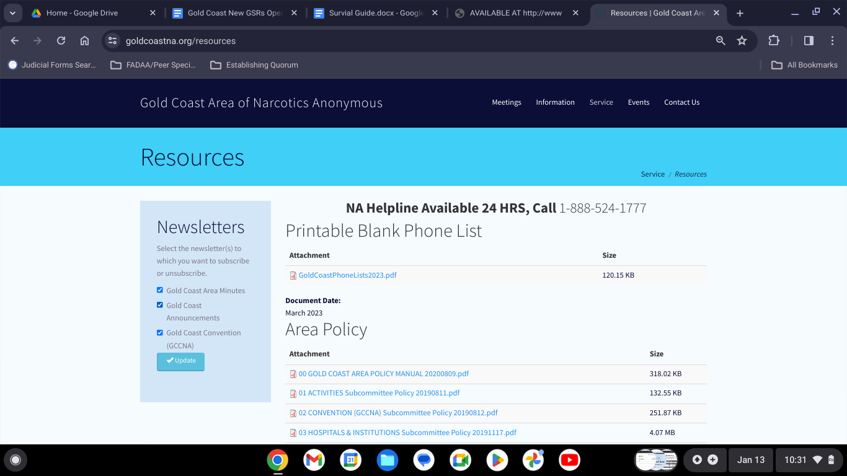
  - Gold Coast Area Minutes - if you choose to subscribe, you will receive the Gold Coast Area minutes via the email you provide when you set up an individual account on the Gold Coast Area Website.
  - Gold Coast Area Announcements - if you choose to subscribe, you will receive announcements and information via email that are relevant and pertinent to events going on the Gold Coast Area
  - Gold Coast Convention (GCCNA) - if you choose to subscribe, you will receive announcements and information via email that are relevant and pertinent to our yearly Gold Coast Area Convention (GCCNA).
- TO SUBSCRIBE - input your email address into the text field located immediately above the “Subscribe” button:
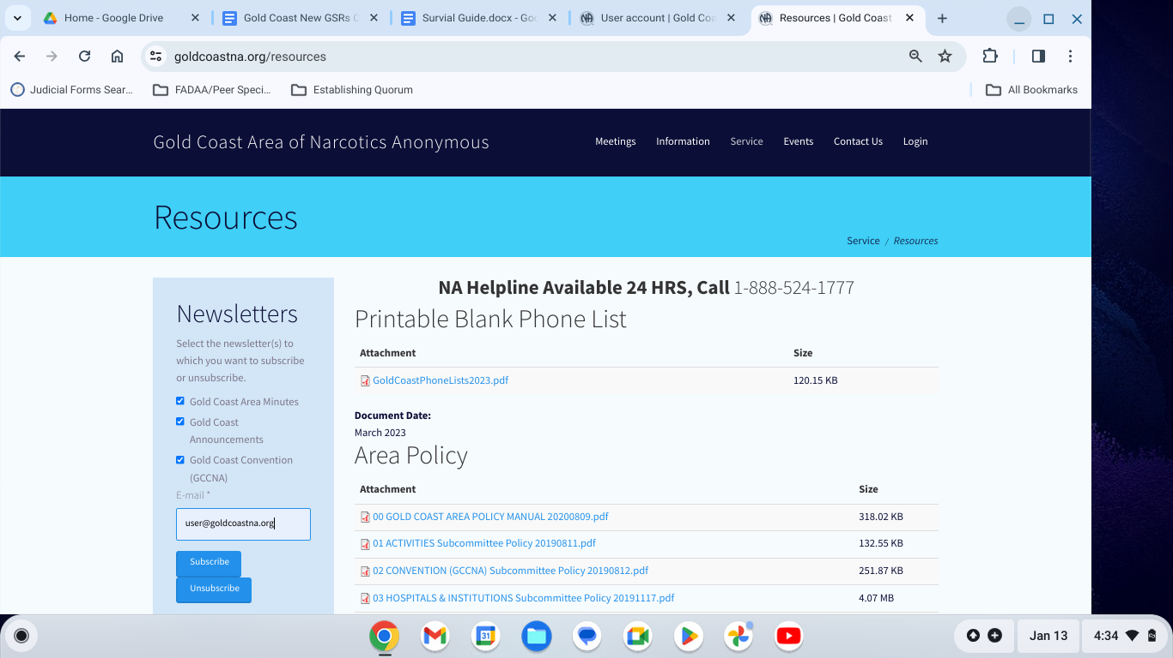

- When you click on “Subscribe” you will see the following screen. Immediately above the “NA Helpline” banner, your will see a green field with an instruction to check your email to receive further instructions on how to complete your subscription(s) as seen below:

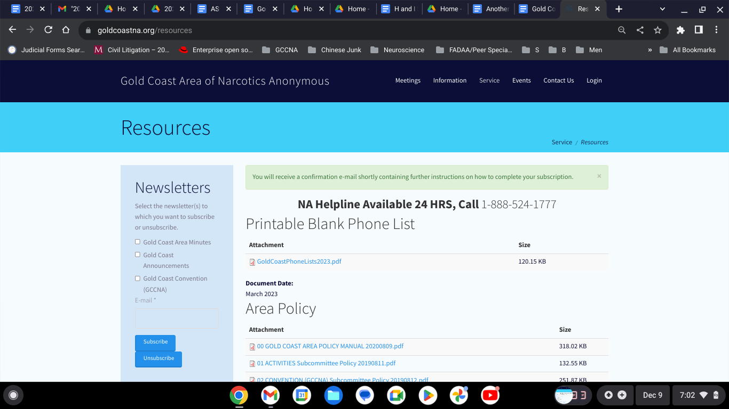

- After you complete the subscriptions, you will begin to receive a confirmation email to the address that you used for the newsletter subscription. Follow the instructions in the email to complete the subscription process.

ACCESSING THE ASC MINUTES AND SUPPORT DOCUMENTS VIA WEBSITE

Even if you have opted into receiving the GCNA ASC Minutes via email monthly, you can also access the ASC minutes by logging into the website using your user ID and password which you set up when you subscribed via the “Newsletter” resource tab. To access the minutes using this method, go to the Gold Coast NA website and scroll to the bottom. You will see a field with a banner titled “Minutes”. Click on “Login” under the “Minutes” tab:
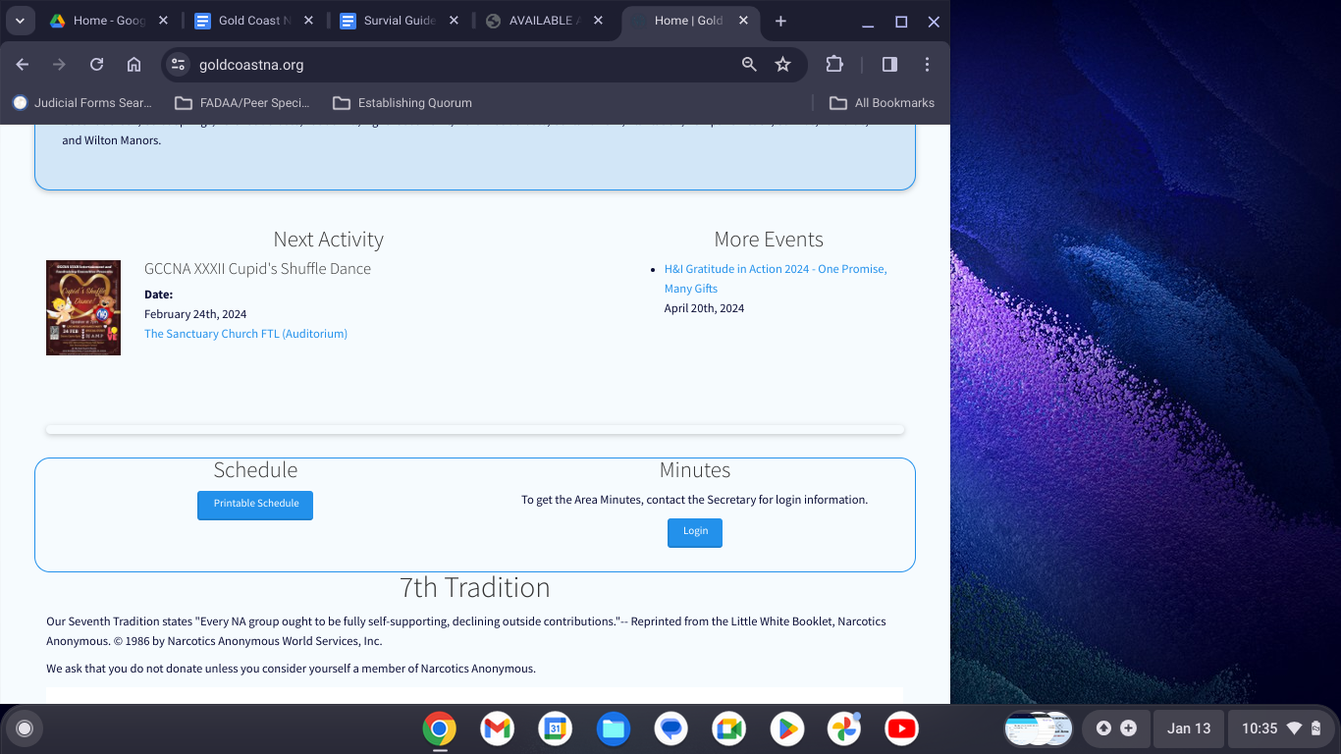

You will be brought to a page titled “Area Service Committee Minutes and Support Documents” as seen below. The minutes are organized by month and year. The support documents can include the Treasurer’s Report (when available and in Microsoft Excel format), Area notice flyers for upcoming events and information from Regional and World (when available).

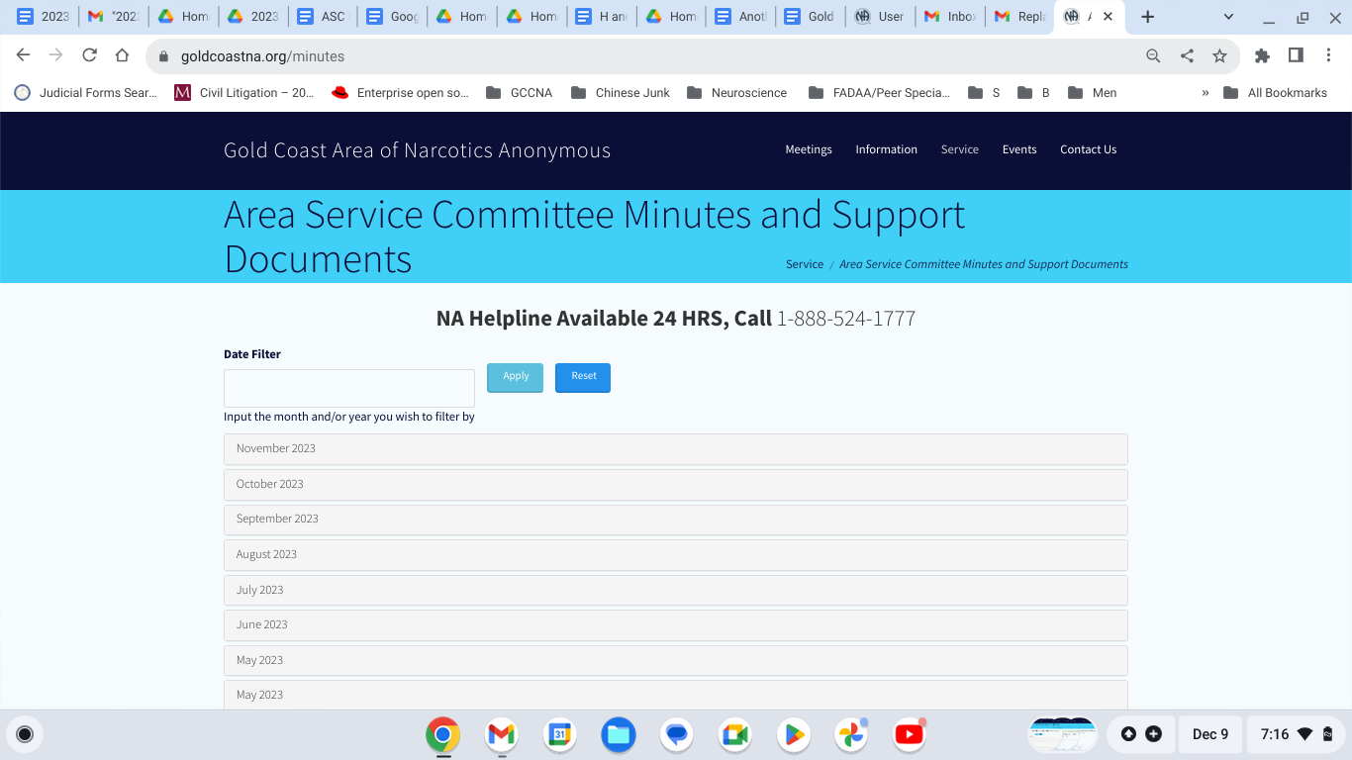
- To access the minutes, click on the tab with the month and year you wish to view. You will be brought to the “.PDF” document as seen below:
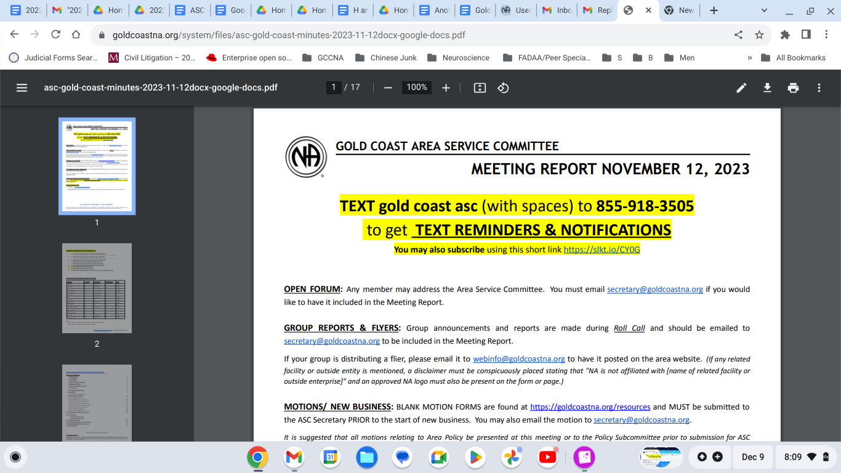
  - Alternatively, you can search the minutes by inputting the month and year you wish to view in the “Date Filter” text field. To open that folder, click the light-blue “Apply” button immediately to the right of the “Date Filter” field. This will present only the folder with the minutes you wish to view. 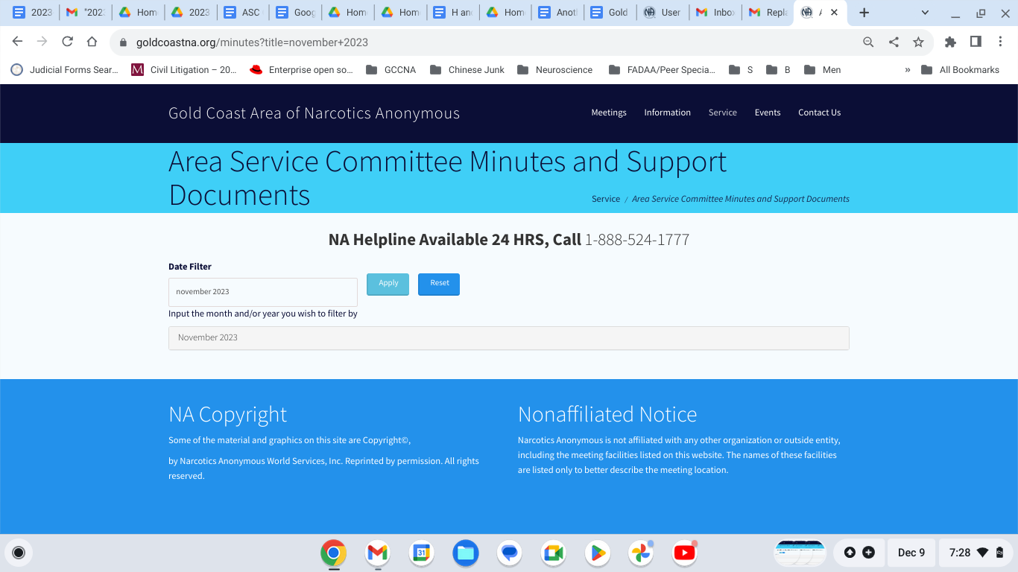
- To open the minutes, click on the folder tab to open the “.PDF” file pertaining to the minutes that you wish to view:
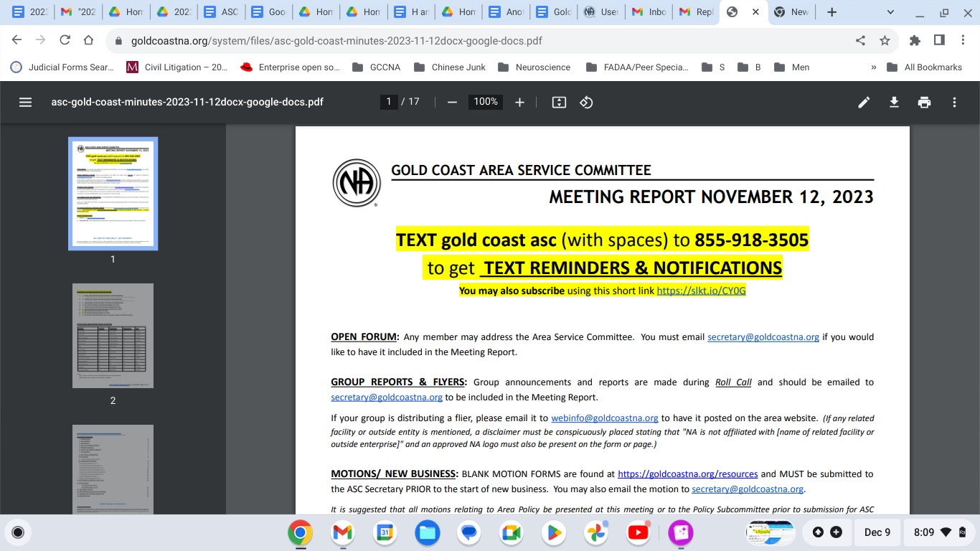

You can also access and view minutes from the Gold Coast Area Service Committee meetings of prior years. It is fun and interesting to see how our Area has evolved over the last two decades!

ACCESSING THE GOLD COAST AREA SERVICE COMMITTEE AND OTHER GOLD COAST AREA SUBCOMMITTEE POLICY DOCUMENTS

- To access the “Gold Coast Area Policy”, click on the “Service” line in the drop-down menu on the left side of your screen. In the upper-right hand corner of the home page screen (above the white “Gold Coast Area” banner, you will see three three horizontal blue lines. Click on this and a separate window will pop-up on the left-hand corner of your screen:

- Then click on the “Resources” line in the drop-down menu on the left-hand side of your screen.
You should get to the “Resources” page.
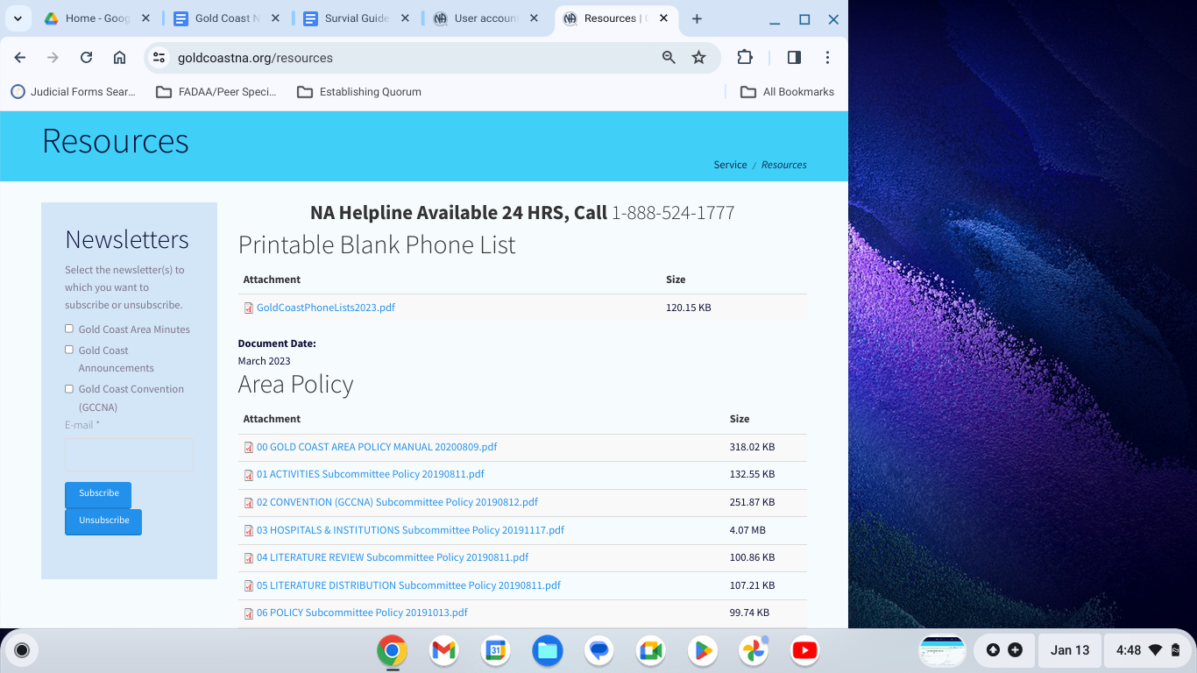

- On the main body of the “Resources” page, you will find the link to print out Blank Phone Lists that include the QR code to access the Gold Coast Area On-line Meeting list
- To access “Area Policy”, click on “00 GOLD COAST AREA POLICY MANUAL 20200809.pdf”
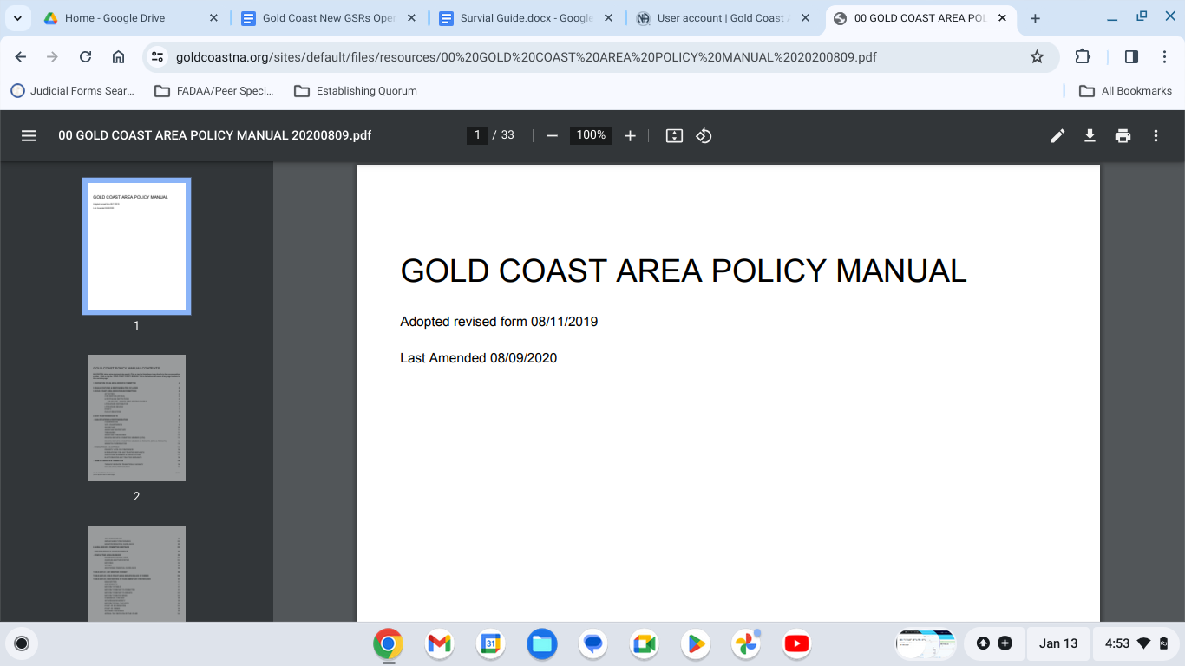

- Click on or scroll down to page two (2) of the “GOLD COAST AREA POLICY MANUAL”. You will find :
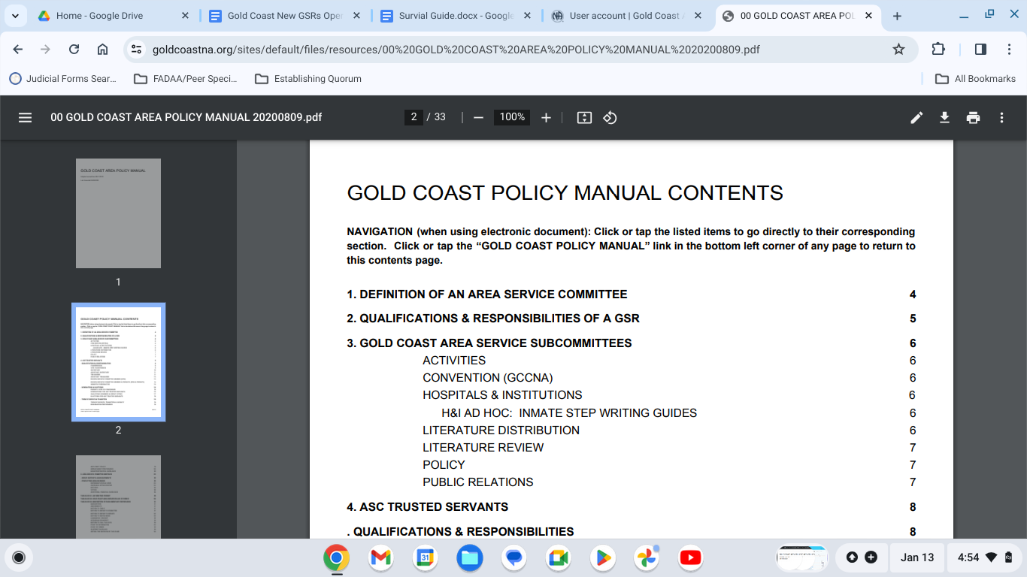

- At the opening of the monthly Gold Coast Area Service Committee meetings, we read:
  - DEFINITION OF AN AREA SERVICE COMMITTEE found on page 4:
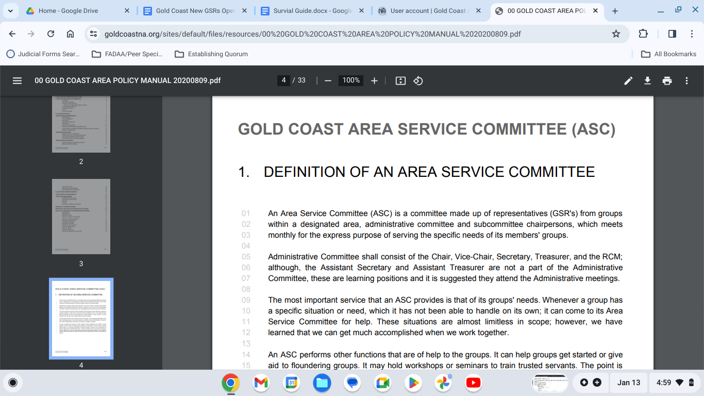

  - QUALIFICATIONS AND RESPONSIBILITIES OF A GSR found on page 5:
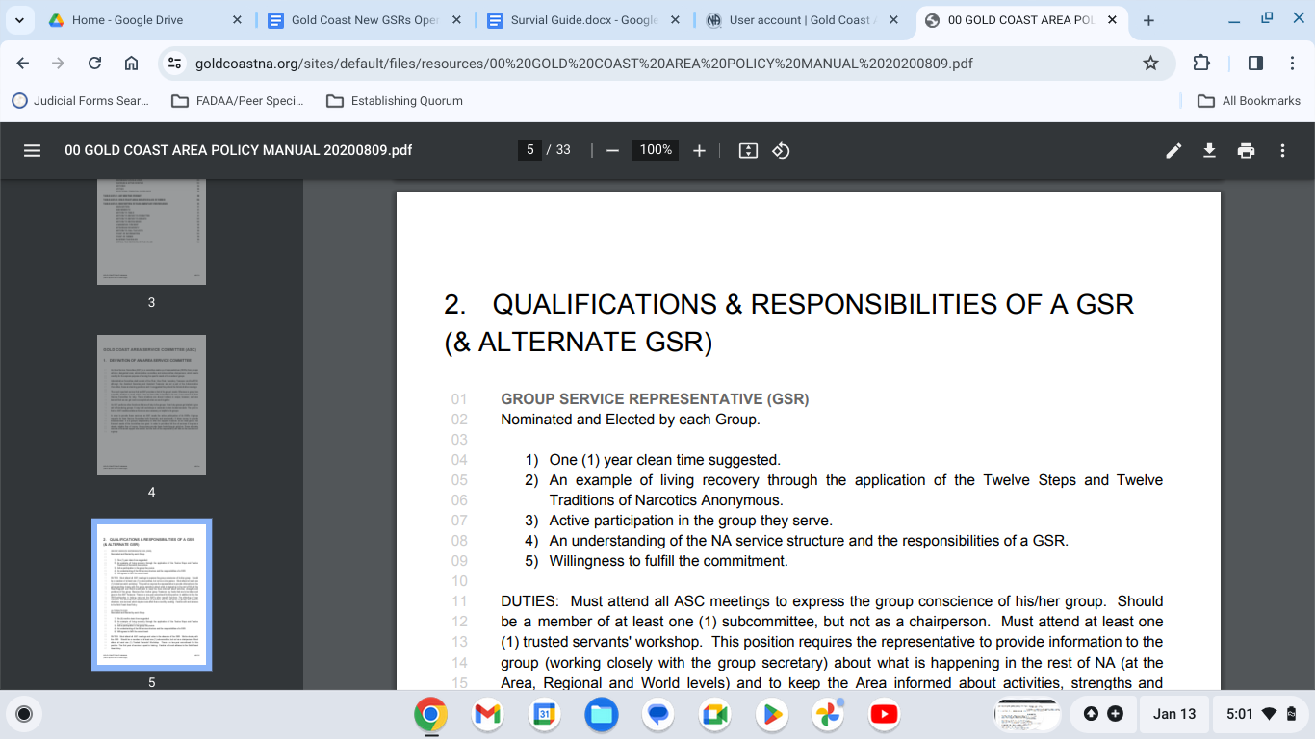

On the “Resources” page, in addition to the “GOLD COAST AREA POLICY MANUAL”, you will also be able to access and look at all of the Policies that pertain to each Service Subcommittee in the Gold Coast Area of Narcotics Anonymous:
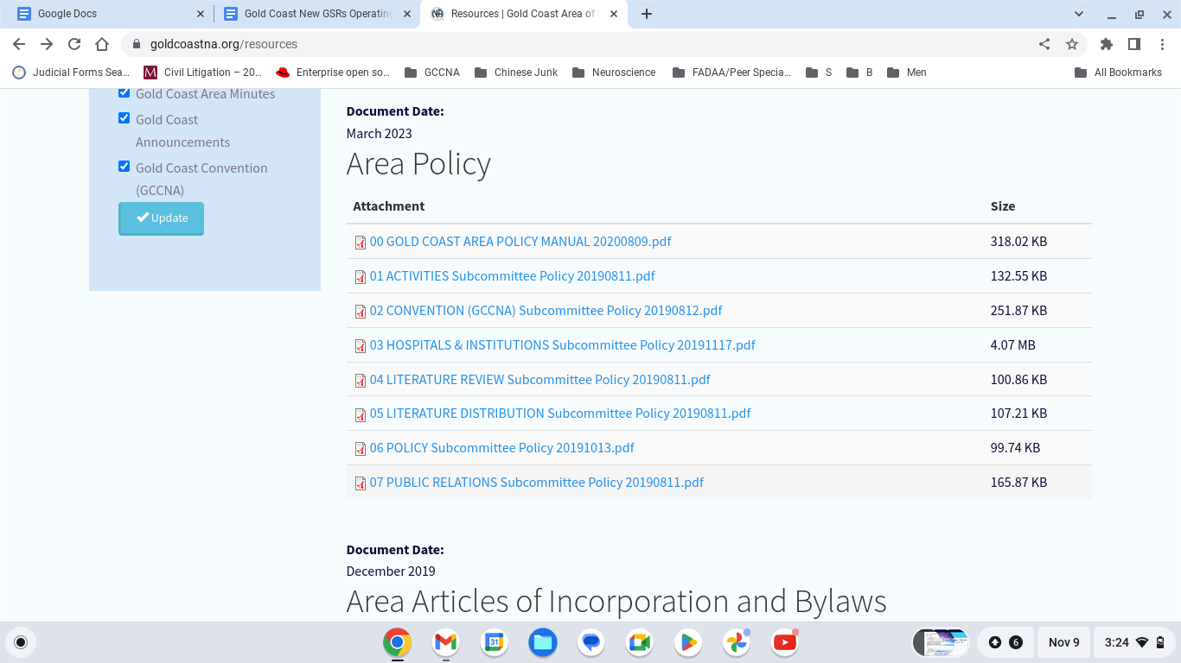

Further down on the “Resources” page, you will find links to the “Gold Coast Area of Narcotics Anonymous:
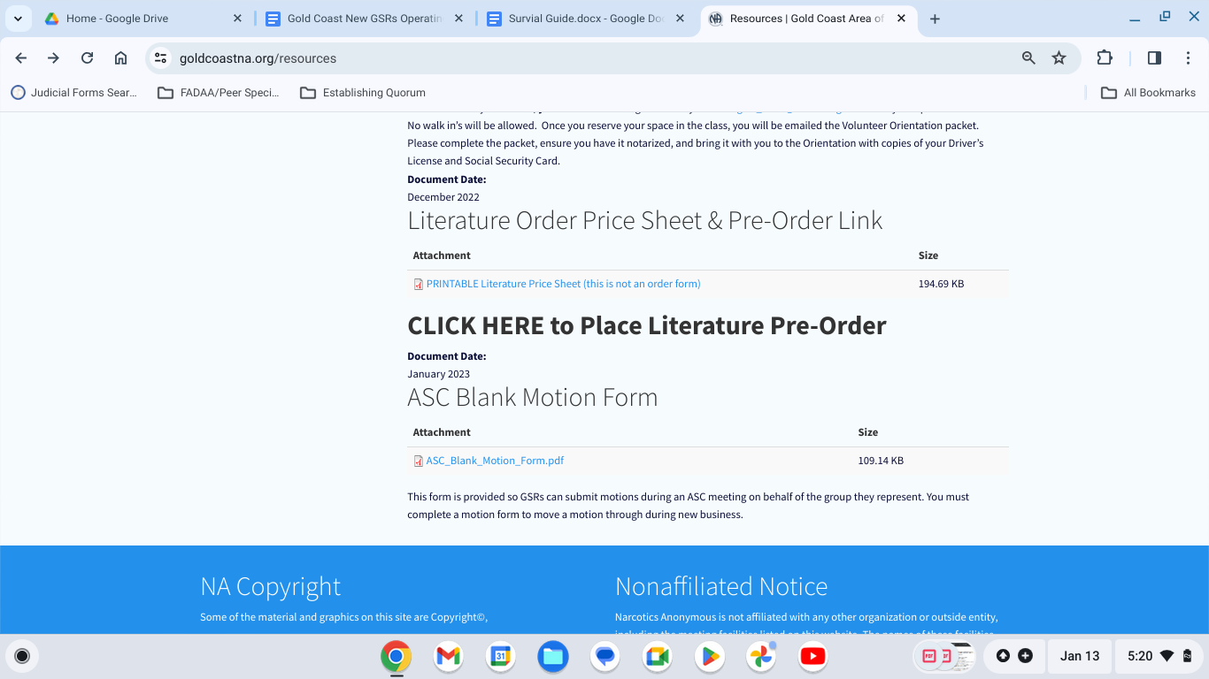
- Literature Order Price Sheet & Pre-Order Link - the Price Sheet is NOT THE LITERATURE ORDER FORM. It is only the literature inventory and price sheet.
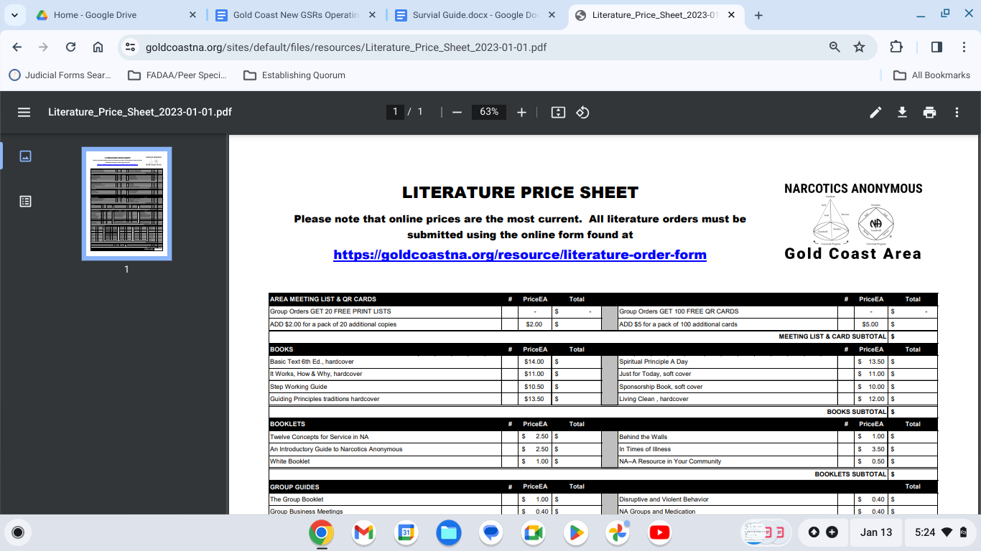
- Literature Pre-Order - click on this to place the literature Pre-Order. ALTERNATIVELY, you may also place your literature pre-order by clicking on the link that is included in the Gold Coast Area Service Committee announcement text that is sent out at the end of the week before the Area Service Committee meeting.
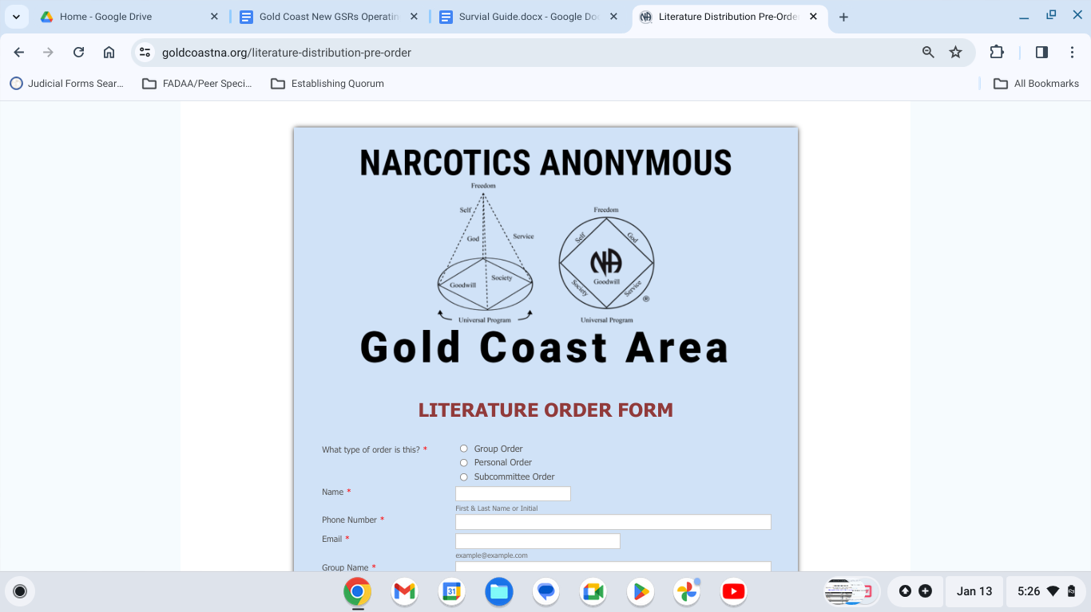
- ASC Blank Motion form - Clicking on this link brings you to a blank motion form that you can use to submit motions to be brought forth to the Area Service Committee meetings. To submit motions, send your completed motion form to secretary@goldcoastna.org PRIOR TO THE START OF NEW BUSINESS. It is greatly appreciated if Motion submissions are typed out. If you are unable to submit your Motion in typeface and must handwrite the Motion, please ensure that the writing is as LEGIBLE AS POSSIBLE.
***NOTE*** - The blank Motion template can be saved to your own personal device for ease of utility
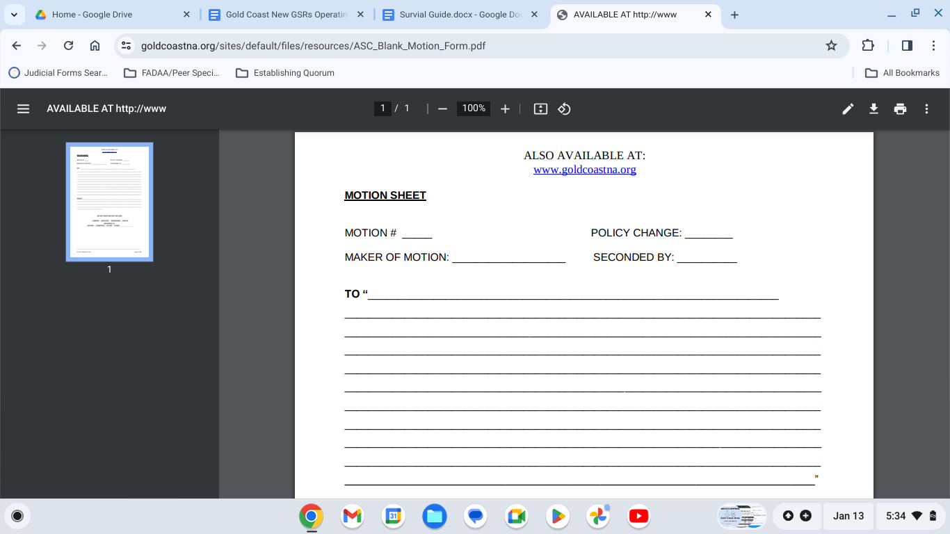

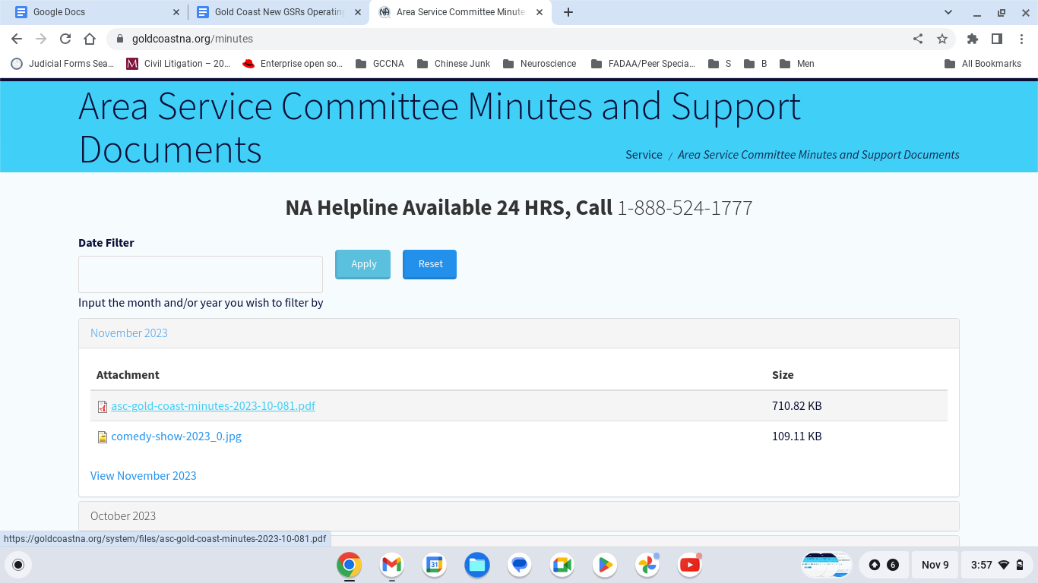
The Area Service Committee meeting minutes are in “.PDF” format. Click on the link for the minutes to open the link and view the minutes:
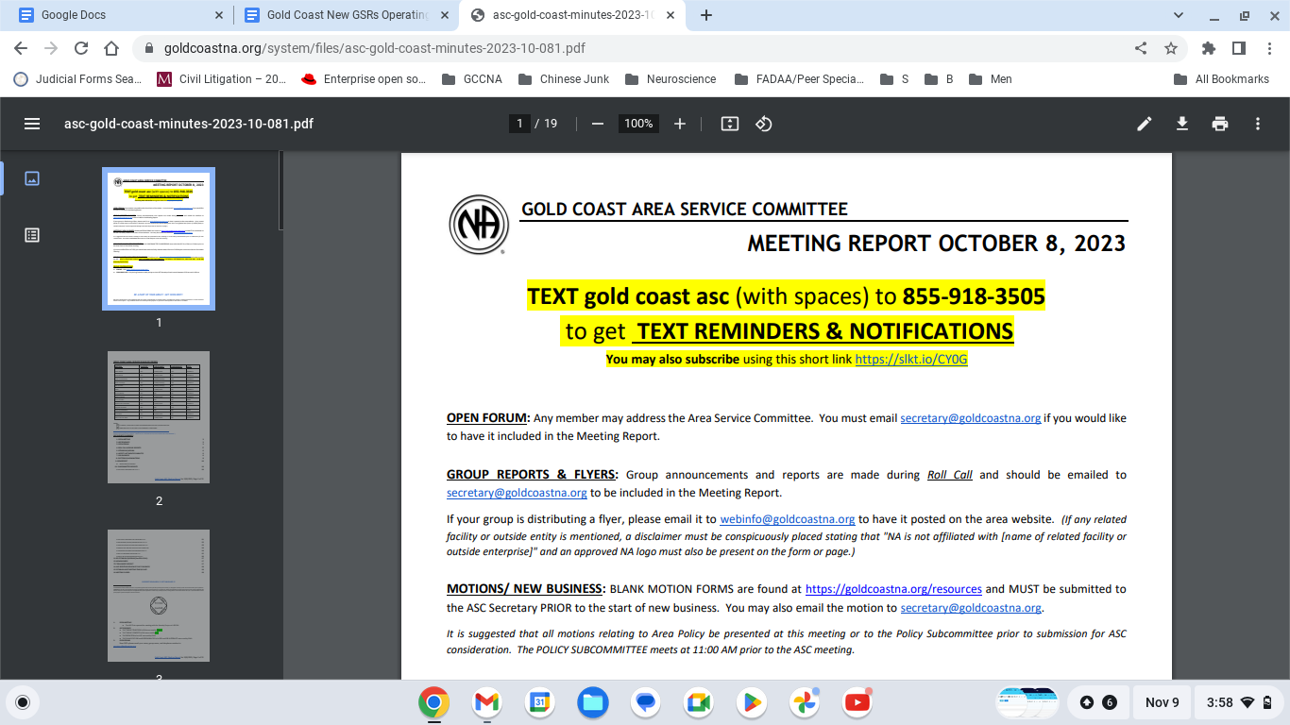
Upon clicking on the link, you will be brought to the *.PDF” document as depicted in the image above.

