**NA World Services Webinar Report**

**“Creating a Safe and Welcoming Atmosphere in NA”**

4 September 2021

World Unity Day, 2021, was marked this year with a two-hour webinar on the theme of “Creating a Safe and Welcoming Atmosphere in NA.” Members from eight NA communities shared their experience on the topic.

The meeting was simultaneously translated into Italian, Portuguese, and Spanish, and live-streamed on YouTube. We were also pleased to be able to provide American Sign Language interpretation. We are truly grateful to the members who offered their translation skills to provide this service.

The meeting opened with a short reading from the Tradition Ten, In Service portion of *Guiding Principles: The Spirit of Our Traditions*:

“When outside issues seem to affect the atmosphere of recovery or the quality of our meetings, we are often more successful when we look for ways to strengthen the atmosphere from within, rather than trying to control things outside of NA. Service meetings and workshops can be vital places for discussion, brainstorming, sharing experience, and offering support to groups struggling with issues that affect our ability to carry the message. Just as in our personal recovery, we don’t have to do it alone. We don’t have many new problems in service; many of our struggles have been addressed in some form or another before, somewhere in NA. Most of our problems have more than one potential solution, as well. When we ask for experience, strength, and hope, and listen with an open mind, we discover solutions we hadn’t imagined.”

Before handing the meeting over to the panelists, a few highlights from the *2020 NAWS Annual Report* were shared. For the first time the Annual Report is in a digital format. This is a more effective use of limited resources, and offers a more dynamic experience for the reader. The *Annual Report* offers a complete look at NAWS’ resources in the course of a fiscal year. It always takes a long time to produce because NAWS operates five locations with different currencies, conducts an outside audit, and the report contains a complex contributions report. Some of the graphics in the report include the free and subsidized literature graph, the NAWS long-term self-support goal, the total number of published translated items, and literature distribution charts. All these and more can be viewed online or downloaded as a pdf: [www.na.org/ar](http://www.na.org/ar).

The eight communities were then introduced by Irene C from the World Board to share about their efforts to increase unity in our Fellowship by trying to ensure that every addict is welcomed to NA and given the opportunity to recover. These efforts include organizing workshops and discussions to address predatory behavior in NA directly, making efforts to welcome members who have not always felt welcomed in NA, and resolving long-standing conflicts. We were also happy to hear from one of our newer members who shared her experience of getting clean in virtual NA meetings.

The first share was from Steve C from New Jersey, who began by talking about the creation of a Fellowship development subcommittee in his home area of Bergen in Northern New Jersey. After developing a variety of tools and workshops, the committee decided to focus on the issue of predatory behavior in NA by organizing a workshop at the Bergen Area New Year’s Eve convention. Steve talked about the challenges encountered locally with the choice of topic, and the efforts of the committee to address some of these while still engaging with the issue. The materials from the Bergen workshops are posted on the Local Service Resources page on na.org – [www.na.org/localresources](http://www.na.org/localresources).

Hammed T was then introduced to talk about the efforts in Kuwait to make recovery available to women in the community. The Kuwait ASC engaged in a focused effort to provide a meeting space for the first women’s meeting in the country, and supported this with workshops on appropriate relationships between male sponsors and female sponsees. There are now four women’s groups in Kuwait offering six meetings a week. More than 50 women are recovering in NA, and PR efforts are focused on carrying the message to women’s rehab facilities.

Kayla D from Canada continued the meeting by sharing her experience of getting clean in virtual meetings. She talked about coming from a place of desperation in addiction to finding a safe place to recover in NA. Her moving share detailed her experience of finding connection, a sponsor, a home group, and service commitments in NA.

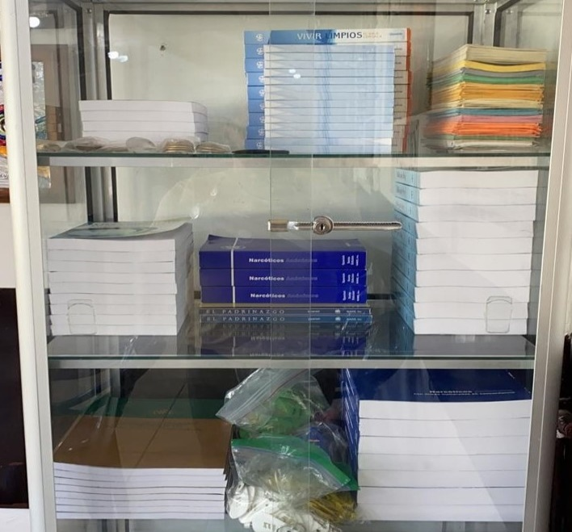Next, Gaby and Luigi from the Latin American Zonal Forum’s Fellowship development workgroup talked about their efforts to promote unity in the NA community of El Salvador. This community had been divided for several years and had no functioning regional service committee. After several attempts to approach the community without success, the workgroup began to offer online workshops on the Steps, Traditions, and Concepts, and followed these up with in-person workshops in June of 2021. These led to reestablishing the supply of literature to El Salvador and a reinvigorated service structure.

Sam K from the UK then shared about the discussions happening in her region about predatory behavior. The region previously created a piece of service material that is posted at [www.na.org/localresources](http://www.na.org/localresources). The possibility of updating the piece has been discussed as the problem has become more prevalent in the virtual environment. The region formed a conscience to bring a motion to the WSC to create a Fellowship-approved piece of literature on the topic, but is aware of the challenges with that approach created by the pandemic and is exploring other ways to continue the conversation.

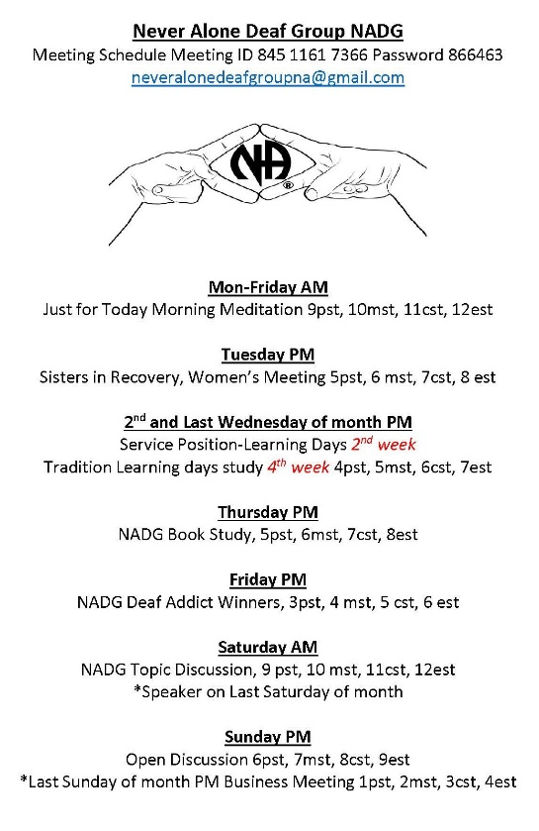Laura S from the Never Alone Deaf Group (NADG) was then invited to share a little about the efforts of this group to make recovery available to deaf and hard of hearing members. She talked about her struggles as a deaf person to access NA meetings and how establishing the NADG has made NA meetings accessible to deaf and hard of hearing members. The group hosts at least one meeting a day, and provides services in a similar way to an ASC, including events, PR and H&I, and translations. ASL resources can be found at [www.na.org/asl](http://www.na.org/asl).

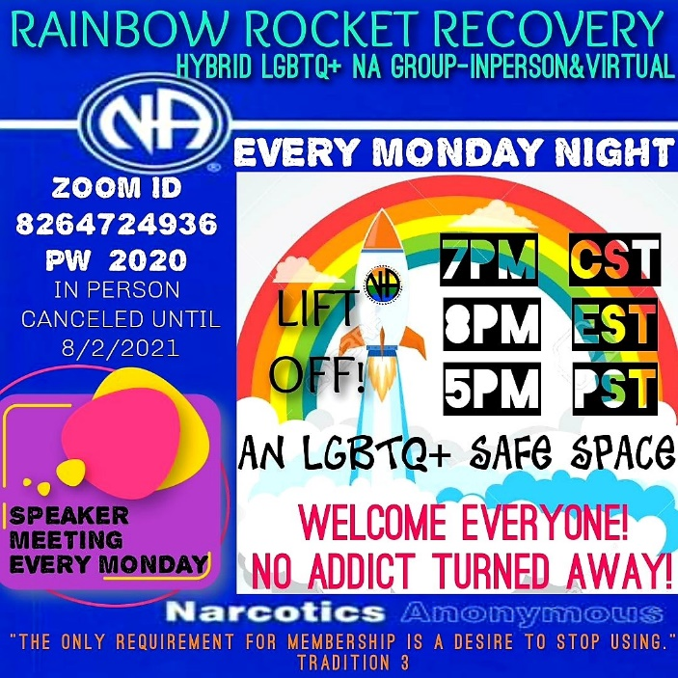Greg H from the Rainbow Rocket Recovery Group based in Alabama continued the meeting by talking about the efforts of this group to create a safe and welcoming atmosphere for all addicts, and in particular NA members who identify as LGBTQ+. He began by sharing his perspective of the challenges experienced by LGBTQ+ addicts and the importance of trust and unity within NA. The group was born from the need for greater representation for the gay community in NA and safer meetings for gay members. When the group switched to a virtual platform at the start of the pandemic members from around the world began to attend.

The final panelist of the day was Tobin D from Hollywood, California, who shared about the predatory behavior workshops she helped to organize in her area. The workshops were created by a workgroup formed to specifically address sexually exploitative behavior in online meetings that began during the pandemic, but also focused on the issue of predatory behavior in the wider NA community. Although it is unreasonable to expect a single workshop to eradicate the issue, it did create the opportunity for some meaningful dialog and empowered groups to take action to address it.

The webinar was then opened for a brief question and answer session facilitated by Tim S from the World Board. Members shared their personal experiences with predatory behavior in groups they served and asked if there is any Fellowship-approved literature that directly addresses the issue, which there isn’t currently other than the *Disruptive and Violent Behavior* service pamphlet. The new draft of “Best Practices for Virtual NA Meetings” was also offered as a resource for creating a safe atmosphere when meeting online.

Following the meeting, the Local Service Resources page on na.org – [www.na.org/localresources](http://www.na.org/localresources) – was reorganized to make locally developed materials on addressing predatory, disruptive, or violent behavior easier to find. Members are encouraged to send any related local resources to worldboard@na.org

Tim then closed the meeting with a final “thank you” to the panelists.