**NA World Services Webinar Report**

**“Attracting Members to Service”**

19 March 2022

The March 2022 NAWS webinar focused on the topic of “Attracting members to service,” inspired by the struggles that many NA groups and service bodies have experienced over the last two years with providing services. We’ve heard from an increasing number of service bodies that they have fewer people to fill positions or work on projects. We asked eight panelists from five different communities to share about some of their successes attracting members back into service. This experience included group, area, regional, and multi-zonal service efforts.

Over 350 members were able to log in to the meeting, with the addition of a number of members at the Florida GSR assembly. The meeting was simultaneously translated into Farsi, French, Portuguese, and Spanish, and live-streamed on YouTube. Once again, we are truly grateful to the members who continue to offer their translation skills to provide this service.

The meeting opened with a short reading from the Step Twelve chapter of *It Works: How and Why*:

“When being of service in Narcotics Anonymous, many of us have chosen to give back to the program in the same way we were helped when new. Some of us whose first contact with NA was through the area phoneline have found it rewarding to serve on the phoneline ourselves. Others have been drawn to hospitals and institutions service work because we first heard the message of NA in a jail or hospital. Whatever form of service we choose to be involved in, we do so with our primary purpose of carrying the message in mind.

Now we must ask ourselves, just what is “the message” we are trying to carry? Is it that we never have to use drugs again? Is it that, through recovery, we cease being likely candidates for jails, institutions, and an early death? Is it the hope that an addict, any addict, can recover from the disease of addiction? Well, it’s all of this and more. The message we carry is that, by practicing the principles contained within the Twelve Steps, we have had a spiritual awakening. Whatever that means for each one of us is the message we carry to those seeking recovery.”

NAWS Updates

Before handing the meeting over to the panelists, Tim, the World Board Chair, shared a few updates and reminded everyone that more detailed information can be found at [www.na.org/nawsnews](http://www.na.org/nawsnews).

The short, interim World Service Conference will take place in April 2022 and will cover essential business and consideration of the Spiritual Principle a Day (SPAD) book for approval. It is hoped that the World Service Conference can meet in person in 2023.

All the information about the WSC is posted on the WSC webpage at [www.na.org/conference](http://www.na.org/conference).

A survey has been posted at [www.na.org/survey](http://www.na.org/survey) to gather thoughts about possible revisions to IP #21, *The Loner*, and will be available until the end of August.

The World Board continues to work towards the long-term self-support goal of member contributions covering at least 70% of the expense to provide services as the board believes that this is the most sustainable means of funding the services provided by NA World Services in the future. There is a new way to contribute directly to NA World Services. Members residing in the US can text the word **VISION** to the number **801801** to receive a link to the NAWS contribution page [www.na.org/give](http://www.na.org/give). This new method may be more convenient for members in meetings on mobile devices, and it’s easy to announce in meetings and events.

The final review draft of Virtual Meeting Basics has been posted at [www.na.org/toolbox](http://www.na.org/toolbox) and [www.na.org/virtual](http://www.na.org/virtual) until late July. After any final revisions are made, this piece will be posted as board-approved service material.

The members attending the web meeting were then asked the question, “Do you receive the NAWS Update emails that are sent when you subscribe to either *NAWS News* or the *Just For Today* daily emails?”

70% of the attendees replied to the poll, and 83% of these subscribe to the update emails available on this page [www.na.org/subscribe](http://www.na.org/subscribe).

After reminding everyone that the 60th anniversary White Book and the electronic version of *Just For Today* are available, as well as grab bags of merchandise from previous world conventions at reduced prices, Tim then introduced the panelists.

Experience, Strength, and Hope

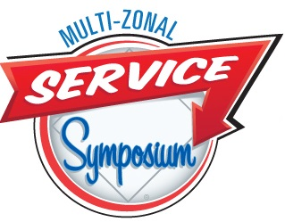The first share was from Amanda and Cindi who talked about the Multi-Zonal Service Symposium (MZSS) they helped to organize. Amanda began by describing the NAWS worldwide workshop she attended in 2007 in Lincoln, Nebraska, and how a group of women from her community were able to use the workshops they attended there to revitalize their home area. Networking at the World Service Conference led to the idea to hold a service event in the central US. She stressed that personal step work by other members is what makes service attractive to her and that she tries to practice this principle when inviting other members to participate.

The MZSS is a service learning day for all levels of service organized by the Plains States, Midwest, and Southern zonal forums that together consist of 26 regions. The first was in 2014, and the MZSS has subsequently been organized every two years in different zones following approval by the groups in each region. All the planning and preparation for the event was conducted virtually and many of the members involved had never met in person until the weekend of the first symposium.

Personal invitations to members to get involved was a crucial tactic in recruiting committee members and panelists. Less confident members were encouraged, and those with specific talents were sought out.

Cindi continued with some key points for success:

* A clear purpose for the event was agreed upon and is frequently referenced – to inspire others and share with them the joy of service
* The event offers workshops that are needed in the host community
* Long-term participation by members is consistent, and new members are also welcomed into serving on the committee
* Information is passed on to new trusted servants so they are able to be prepared

The next Multi-Zonal Service Symposium will be in Detroit, Michigan, October 13 – 14, 2023. Details can be found at mzssna.org.

Next, Katie in Florida was asked to share about the efforts of the Sunshine Sisters group she helped to start, and its focus on welcoming and involving new members.

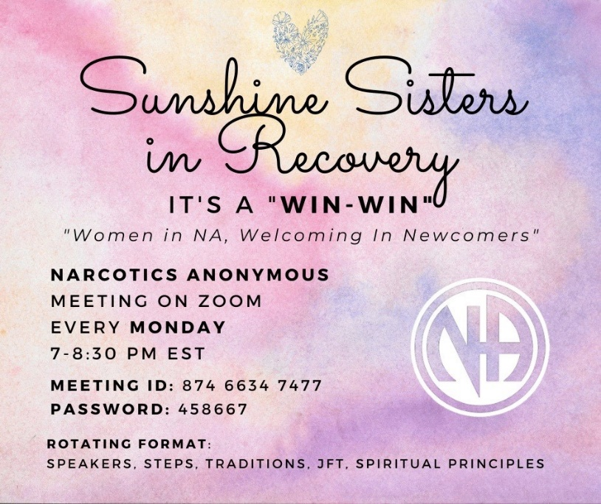The group was inspired by the stories heard in a 24/7 marathon meeting started at the beginning of the pandemic. Katie shared her perspective that having a more outgoing, engaging personality benefitted the host of a virtual meeting. In the same way, the Sunshine Sisters group has tried to attract members with well-designed flyers and different types of service positions. The group has social media coordinators that consistently post information about the group in over 250 Facebook groups every week.

Generating excitement, finding ways to put members’ skills to good use, and innovating within the framework of the Traditions has helped the group to grow and carry the message.

Gabi from Costa Rica then presented some of her experience being involved in service in this vibrant NA community. She began by sharing some of what she learned attracts members to service during an Issue Discussion Topic workshop focused on the topic at the Latin-American convention in Costa Rica in 2019:

* Members feel valued
* 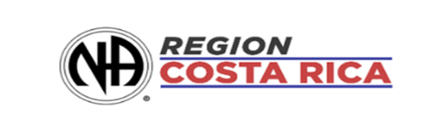All members are heard
* Information is provided and members are inspired
* A Vision for NA Service is incorporated in workshops
* Members experience empathy and gratitude and seek to carry the message to others

The region created a work plan at its planning conference in January 2022 to post in online GSR chat groups, and to visit groups in person to share about the Vision and the reinforce the importance of NA service. Gabi helped to revitalize the PR committee by reaching out to groups, visiting group support 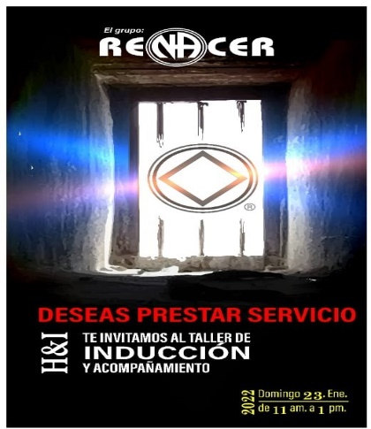forums (GSFs), and conducting workshops. There are currently ten trusted servants on the committee, including a vice-chair.

H&I workshops are presented at groups every two months by the H&I chair and vice-chair, and there are currently 65 trusted servants on the H&I committee. Other Fellowship development efforts are focused on supporting new groups, visiting GSFs, and hosting learning days to educate members and promote an atmosphere of recovery. Regional delegates are tasked with attending GSFs and supporting groups, facilitating regular Traditions and Concepts learning days and regional workshops, and participating in LAZF and NAWS webinars and workshops.

Jeff from El Paso, Texas, then talked about the revitalization of PR services in their community. He spoke about the challenges the PR committee encountered as a result of the pandemic, which included the committee shrinking from 15 members to three or four that were still involved. Slides were shown of the health fair the committee was able to attend as pandemic restrictions were eased, flyers that were created for PR week events, and a virtual event for Recovery Month in September. The committee was also able to respond to questions from members getting clean in virtual meetings by organizing a virtual event focused on finding and participating in a home group.

El Paso is a bilingual community; it is close to both New Mexico and Mexico. A slide was shown of a bus placard in English and Spanish that was posted on city buses for three months. A virtual regional convention was also organized in 2021 that the PR committee was able to assist with, as well as a New Year event focused on service.

Virtual PR presentations were organized for local agencies and bilingual placards have been distributed. Jeff then introduced the current PR chair, Pete, who talked about the rebuilding of the PR committee through consistency, continuity, and a focus on core PR principles.

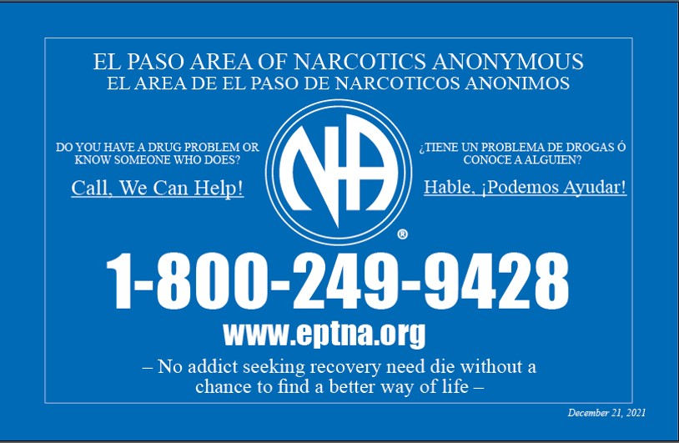

The final panelists were Donna and Charles from the We Do Recover virtual area in the Chicagoland Region who were invited to share about how they have created an atmosphere of recovery in their service meetings. Donna began by reviewing the history of establishing virtual meetings in Chicago at the start of the pandemic and early efforts to involve themselves in the local service structure. The decision to form a virtual area grew from these efforts. After existing for two years, the area now consists of 50 meetings in several states and has created procedures that help the area run smoothly.

Charles continued by reviewing the ideas that led to creating an atmosphere of service, including:

* Creating a space where involvement is meaningful
* Focusing on an atmosphere of service in workgroups and committees using the principles of K.I.N.D.N.E.S.S.
* K. – Keeping it short, sweet, and simple
* I. – Include everyone as much as possible, especially newcomers
* N. – Nurture the relationships needed for effective service
* D. – Development: Training, mentoring, and encouragement
* N. – Necessary: Stay on task, take breaks, and avoid unneeded comments
* E. – Ego: Check it at the door and be the best you can be
* S. – Snacks for yourself and others
* S. – Survey: Ask attendees and groups about presentations, services, and events

The area can be contacted at [wdroarea@gmail.com](mailto:wdroarea@gmail.com) and more information is available at <https://wedorecoveronline.org>.

The remainder of the meeting time was spent on questions and brief sharing from attendees.

Questions and comments focused on the importance of NA unity to keep NA service attractive, ways to involve new members in virtual service, contributions by virtual meetings to NA service bodies, challenges with finding consistent trusted servants for virtual meetings, the reality of limited resources, and involving virtual groups in service and the Fellowship’s decision-making processes. Flexibility, diversity, and communication were all principles offered by the panelists in response to attendees’ questions.

In response to a question about whether the NAWS would be offering an updated PSA, Tim reminded everyone that locally developed materials are posted at [www.na.org/localresources](http://www.na.org/localresources).

Tim then closed the meeting with a final “thank you” to the panelists and the translators, and to everyone for attending, and the Third Step Prayer.