**Guidelines for Zoom Co-Host Chairperson Technical Instructions**

**Ensure you have a good Internet connection!!**

There are two documents for the Co-Host-Chairperson.

1 – Technical instructions

2 – Co-Host Chairperson & Meeting Format

Rename yourself to include your volunteer position, ie. Franney-Chair, Franney-Greeter, Franney-BreakOut, Franney-Serenity

Once you are on Zoom, send a private message to notify the Tech-Host that you are present. At the close of the meeting, the Tech-Host will make you a Co-Host. Once you are a Co-Host, verify all of your Zoom support team members have Co-Host ability.

Do not hesitate to contact Tech-Host if you are having any difficulties.

To make donations/Contributions to this event.

1. MOBILE: Text code XXXX to XXXX (replace X with actual event message and code)

   (User will receive text reply with link to Donate)

2. COMPUTER: Visit (your website) and click the **"DONATE" button** next to the video stream.

If you notice a participant’s virtual *HAND* raised, notify the Breakout Room Information Support Co-Host.

*Before starting, verify all Co-Hosts have Co-Hosting ability. Each Co-Host has distinct roles.*

Know the roles of Co-Hosts and support one another. If you see a participant’s virtual hand is raised, notify Breakout Room Information Support Co-Host.

1. Tech-Host - these are the highly technically skilled team of people who develop their own guidelines. Each technical team/person may be different depending on the style of the event.
2. The Co-Host-Chairperson - This is the person who facilitates the meeting, announces the speakers and coordinated, audio-visual content.
3. Waiting Room Greeter - The face and voice of NA Welcoming and identifying guest participants. This person requests all participants rename themselves upon entry to the main meeting with First Name, Last Initial, State if USA and Country if non USA, i.e., no “iPhone” or “Galaxy 10” “James T. Kirk,” we have to watch out for “interrupters.” Our Greeter is our first line of defense.
4. Breakout Room Information Support - providing NAWS information and support including the Recovery Companion App, how to make a one time and recurring contribution, as well as the NA Meeting Finder App. This person should also be proficient with navigating [na.org](http://na.org/).
5. Serenity Keepers - taking down video or offensive default photos. Our second line of defense. This person(s) must always watch videos & photos to make sure no one is using; no one is doing anything inappropriate while on video. Check videos & photos for violent and offensive profile photos. If it is questionable, immediately “turn off video.” If a participant wants to know why, invite them into a private chat to explain the reason-use discretion.

*\*\*\*Reminder for all Co-Hosts: Do not admit participants in excess of room capacity; this is so volunteers and speakers for the next session can log on.*

**COMMITTEE: PLEASE CONSIDER REVISING THIS SECTION BECAUSE THIS IS WHAT WE USED AND THE TECHNOLOGY MAY CHANGE**

**How to Section**

**Screen Sharing:** Share your screen as a host, simply click the green “Share Screen” button located at the bottom of your screen (image 1). Then select the file you wish to share (image 2)

Image 1

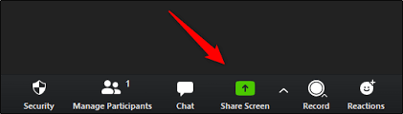

Image 2

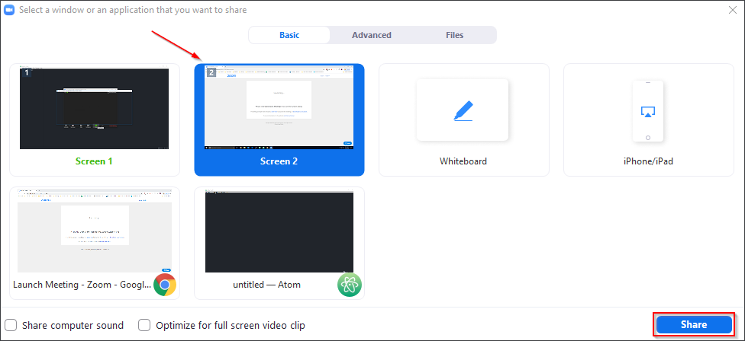

**Video-Sharing with Sound:** to share both audio and video you will have to click on “Share Screen,” and then click on **BOTH** the checkboxes on the bottom left - they are labeled “Share computer sound” and “Optimize for full-screen video clip” (image 3)

Image 3

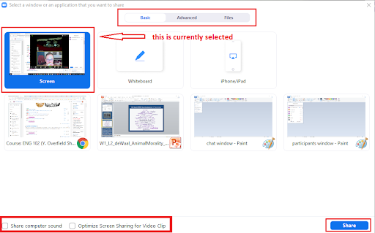

**Note: If your focus is on audio-only, and not sharing a video or clip; then you do not need to check the second box labeled “Optimize for full-screen video clip.”**

**Connect the Audio Readings: Recorded in English, French & Spanish**

<https://thejourneycontinues2020.org/intro/>

**Streaming**

If the meeting is not streaming you will start the streaming. If you see the live stream indicator in the top left of the zoom window, no action is needed. If you do not see the live stream indicator, locate your “more” button, click on live stream.

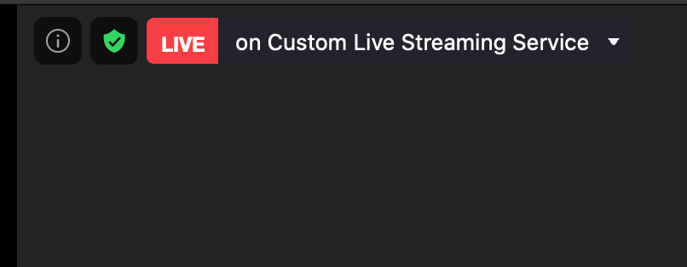



Click “Live on Custom Live Streaming Service”.

A new browser window will open, fill in the settings as mentioned in the green box above the fields, you can copy and paste each item respectively:

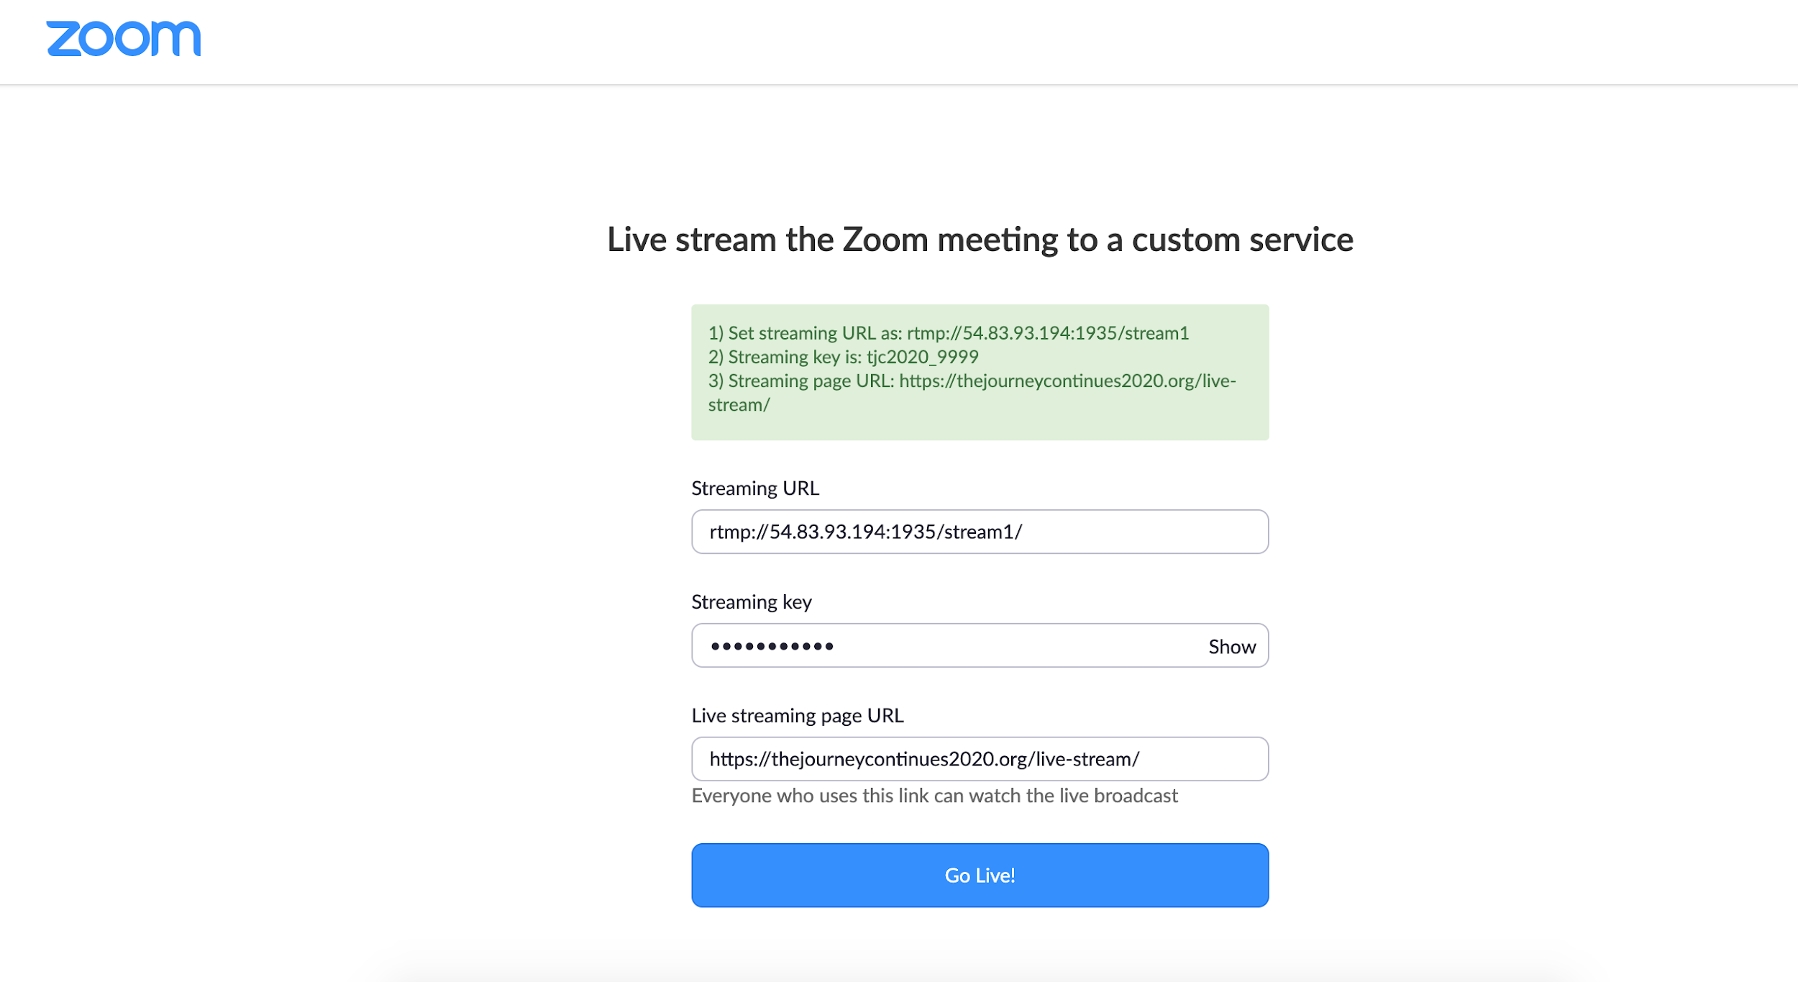

Once you have completed, click “Go Live!”. You will see the below indicator as the live stream is going.

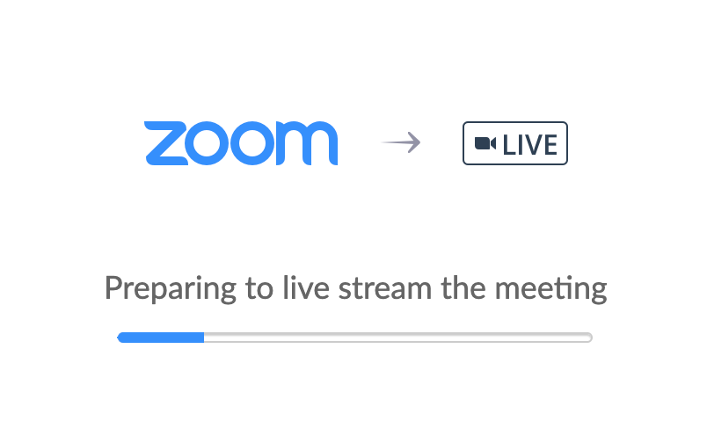

If this was successful you will see it redirect to the website with a video player and you will see the live stream. Also, if you go back to the Zoom window you will see the Live indicator in the top left column.

