**REGIONAL COMMITTEE**

**MEMBER**

**(R.C.M.)**

**ORIENTATION PACKAGE**

**This package was created as an informational resource to help RCM’s more effectively serve their Areas. It is not meant to be the final word or complete description of their duties but merely a suggested guide and should not override any Group/Area autonomy. We hope that this will be an inspiration to more effectively serve in the RCM position.**

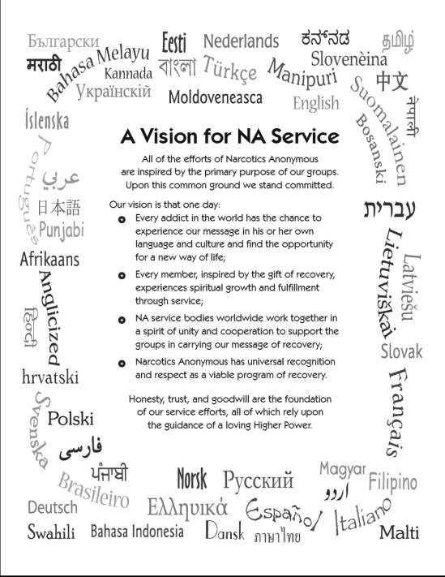**WELCOME TO THE AL-SASK REGIONAL SERVICE MEETING**

The following was written to welcome and provide information to help you better serve in your new position as a Regional Committee Member. All positions are important to carrying the message of recovery so thank you for your service! We want you to know that we are all here to support and help you to get comfortable at your new service position in this Region. Our first suggestion is to obtain and read the Guide to Local Service and familiarize yourself with Regional Service and its purpose.

**WHAT DOES THE REGIONAL SERVICE COMMITTEE DO AND WHAT IS THE EXPECTATION FROM THE REGIONAL SERVICE MEMBER**

**(Reproduced from the Guide to Local Service P.50)**

Regional Committee Members are just that: They serve as the core of the Regional Service Committee, a body that coordinates service forums throughout the Region and is responsible for the AL-SASK Regional Convention. The Regional Service Committee also serves year round as a contact point between NA World, CANA, and local services. Detailed information on the services provided by Regional Service Committees can be found later in the Guide to Local Services.

RCMs keep their areas in touch with the larger world of NA by providing information on activities in neighboring areas, functions being sponsored by the Regional Service Committee, reports relevant to subcommittee affairs, and important issues being discussed at various levels of service.

Both the region and its areas depend on RCMs to be well-versed in NA service practices and principles. RCMs should be closely acquainted with the Twelve Traditions and Twelve Concepts; the fundamentals of service in our fellowship. Familiarity with all published service manuals and bulletins puts the resources of the whole fellowship at the RCM’s fingertips.

RCMs should carefully study the reports from their own areas’ groups, and workgroup chairs so that they can pass their areas’ experience on to others at the regional meeting. RCMs will be more effective contacts between their areas and the regional committee if they take time to talk personally with other participants in their area workgroups. That way, they can get a better idea of what needs and concerns the regional committee should address.

Regional committee members typically serve two-year terms (this varies area to area). Most areas have two RCMs serving at any one time, typically a Regional Committee Member and Alternate. This helps the Regional Service Committee maintain a balance between experienced members and those just learning the ropes. It also ensures that a Regional Committee serving only three or four areas will have enough members to be able to do its work.

These are both best described in the Guide to Local Service on pages 93, 97, and page 50 of the Guide to World Service. As well, there is a wealth of service experience sitting at this table more than willing to help. In NA we tend to use a lot of acronyms so if there is something that you do not understand please do not hesitate to ask.

***A Short List of NA Acronyms***

***ASC - Area Service Committee -*** A committee created to provide common services for NA groups in a specific locale, composed of GSRs, ASC officers, and subcommittees. Usually, part of a region to which it sends RCMs.

***CAR - Conference Agenda Report -*** Comes out every 2 years before the World Service Conference and contains the business and issues that will be considered at the biennial WSC.

***FIPT - Fellowship Intellectual Property Trust -*** NA owned rights to all NA literature, logos, symbols, trademarks, and copyrights.

***CAT – Conference Approval Track -*** The items in the Conference Approval Track (CAT) are considered new business at the Conference. That means participants have an opportunity for discussions during the Conference week before making any decisions on these items.

***GLS - A Guide To Local Services In Narcotics Anonymous -*** Handbook explaining the NA service structure from the group level to the regional level. Does not include the world services structure.

***GSR - Group Service Representative -*** A meeting of the group’s representative to ASC. ***H&I - Hospitals and Institutions -*** A subcommittee of the ASC, which takes panels into places where addicts do not have access to regular NA meetings in order to carry the message of recovery in NA.

***NAWS - Narcotics Anonymous World Services -*** Refers to the legal name of World Services.

***PI - Public Information -*** Part of NA (and usually a subcommittee of the ASC and / or RSC) devoted to carry the NA message to government and private agencies, the public media, community leaders, health professionals, and the community at large so addicts seeking recovery are sent to NA.

***PR - Public Relations***An NA subcommittee of the ASC devoted to providing information about NA and the Area to members, prospective members, professionals (physicians, councillors, etc.), institutions (schools, community based organizations, etc.) and to the public with a view to increasing awareness of NA and its message of recovery, and by developing positive, independent relations with individuals and groups outside of NA. Public Relations is responsible for: arranging for members of NA to participate at speaking engagements about the Area and the NA program, and maintaining the Area NA Helpline.

***OR - Outreach -*** Outreach is a subcommittee of the ASC that helps to connect Area members, groups, meetings, and individual addicts with the established NA fellowship, including arranging for members to travel to other places with well-established NA groups and fellowship, to meetings in smaller locations.

***RCM - Regional Service Member -*** Elected by an ASC to represent their area’s conscience to the RSC.

***RSC - Regional Service Committee -*** Service body that serves NA areas that comprise it, composed of RCMs, RDs, and others as needed.

***RD - Regional Delegate -*** Elected by an RSC, WSC participant who represents their NA region at the WSC.

***CANA/ACNA –*** Canadian Assembly of Narcotics Anonymous

***CCNA –*** Canadian Convention of Narcotics Anonymous

***WSC –*** World Service Conference

***WCNA –*** World Convention of Narcotics Anonymous

***GSR Assembly***

***ARCNA –*** Al-Sask Regional Convention of Narcotics Anonymous

***BMLT –*** Basic Meeting List Toolbox

***WELCOME TO THE AL-SASK REGION!!***

**RCM Orientation Sheet**

**What is a RCM?**

-A trusted servant of their Area.

-The voice of their Area at the Regional Service Committee. (RSC)

-The voice of Region at their Area.

-The financial link between their Area and the Regional Service Committee.

-The Area’s main source of information about service, activities, and events in the region and CANA/ACNA.

.-The Area’s source of information on how to get involved in regional service work.

-An important source of information for the Area about area policy, the 12 Traditions, and the 12 Concepts. -A core part of the RSC, alongside their neighboring area R.C.M.’s.

**How do they do it?**

-Participate at their home group meeting regularly.

-Participate at their ASC meetings.

-Participate at the RSC meetings.

-Report to the RSC the Area status, events, contribution, successes, problems, and concerns.

-Bring issues from the RSC to the Area for an Area conscience and report back to the RSC. -Learn about the workgroups of the RSC. Join at least one of the RSC workgroups and actively participate.

• What types of workgroups are there?

• What do these workgroups do?

• When do they meet?

• Who may attend?

• Which workgroups need support?

-Learn what the Regional Service Committee (RSC), Zonal Forums (ZF), World Service Conference (WSC), World Service Office (WSO), etc. are.

-Study the Guide to Local Service and the RSC Guidelines. .

-Help keep meeting information updated for Region and Narcotics Anonymous World Services (NAWS) databases via the Regional Website.

-Ensure their Area is updating the BMLT and the Yap phone list of members willing to be on the list regularly.

**Qualifications for a RCM**

-Is an addict.

-Participates at the Area they represent.

-Has a willingness to serve.

-Has the suggested clean time of their area.

-Has knowledge of the service structure of NA or the willingness to learn it.

-Has the willingness to learn the duties of a RCM.

**How does a Region take care of its business?**

*Some of the ways include but are not limited to:*

-By applying the Twelve Traditions and Twelve Concepts to all its affairs.

-By holding an Regional Service Committee (RSC) meeting monthly.

-By using the resources (money, people, time) sent by their areas , they participate in workgroups.

-By developing a regional conscience through discussion with RCM’s.

-By holding elections of trusted servant positions as needed with prior notice if possible.

-By sending their RD and/or AD to the CANA/ACNA and WSC. .

-By creating workgroups when needed.

-By holding admin meetings as necessary.

**How does a Region communicate concerns to the RD/ AD team?**

-The RCM or any member may bring concerns to the Rd/AD team attention at the regional meeting, or any other method deemed appropriate by the region (e.g. e-mail, phone call, etc.).

**What about RCM reports? How often?**

-Usually RCMs make one written report to the area letting them know what was discussed in the region. They also make a written report to the RSC meeting for every January, March, June, and October Regional meeting, which is sent to the Regional secretary no less than 20 days ahead of the meeting.

**What about work groups?**

-Sometimes work groups are formed to take care of regional or workgroup tasks. . They meet regularly and report back to the Region.

**What is a group conscience?**

-Is the practice of the 6th Concept.

-An expression of God's will.

-Is best for the group (homegroup, area, or region) as a whole.

-Is the practice of placing principles before personalities (Tradition 12)

**When may a regional conscience be initiated?**

-A regional conscience may be initiated anytime during the RSC meeting if a member feels it's necessary.

**How does the regional contribution get from the Area to the Region?**

-The area decides at their regular ASC meeting if and how much of a contribution they can make to the RSC. A cheque is written, or money is prepared and sent with the RCM or Alternate to the RSC meetings. The treasurer will give you a receipt for you to give to the Area Treasurer. These contributions will vary from area to area.

**What could an R.C.M. report include to be taken back to the ASC.**

-Number of Areas that attended the RSC.

-All open positions at the RSC and CANA/ACANA.

-Information about RSC workgroups and which one you are part of. Also which work groups have openings for members. .

-Time and place for the next RSC meeting.

-Regional events, i.e. Regional Assembly, Conventions, PI and H&I presentations, Zonal Forums, Conference Agenda Report (CAR) Workshop etc.

-When the Regional Elections are held.

-All proposals sent back to Areas for discussion and group conscience.

-Content of major discussions/concerns/successes at the RSC.

-Any other information regarded as important by the R.C.M’s conscience.

-Events happening in other Areas and Regions.

-Events happening around the world. Usually found within the Regional Delegate report.

- Supply an electronic copy of the RSC meeting minutes.

**What could an R.C.M. report include to the RSC**

-Area events, i.e. Learning days, picnics, campouts, sporting events, conventions etc.

-Their financial contribution (if any).

-The number of groups that are a part of their area.

-The number of groups who have been attending their last two (2) ASC meetings.

-Announcements of the status of their area positions.

-Any new groups that have joined their Area.

-Any updates made to the BMLT, World Service and YAP phone numbers.

-Major concerns/discussions/successes from ASC

-Any other group information that may affect NA as a whole.

-When the ASC elections are drawing near with time and place of said elections.

-The mailing address for the area.

-Where and when the ASC is held.

-Clean Date Birthdays

January

RSC checks in meeting.

ALSASK Regional Convention Budget and seed convention.

February

CAT/ CAR workshop on WSC years

March

Audit  
Treasure’s nomination

RSC

Regional Convention Chair ratification

Annual Budget Approval   
Deadline for GSR Assembly numbers

June

RSC

Form work Group for Policy and packages review

October

Service Body elections for RSC

BMLT and YAP

It is the RCM’s and their own area's responsibility to take care of updating the BMLT.

The RCM will ensure with their area that the phone list of members willing to share it for YAP is updated regularly.

RCM’s will work with the Region’s Public Relations person or sub committee if they need help.

***BMLT Help***

This is a basic guide to help you with the ***Basic Meeting List Toolbox (BMLT)***

login to https://canaacna.org/meetings/main_server/index.php?admin_action=logout Enter login account and password

Once logged in you will have a menu with the following.

**Server Administration**

**Meeting Editor**

**Meeting Browser**

**My Account**

***Server Administration***: unfortunately, there is nothing to help you with this.

***Meeting Editor***

In this area there are the following: **Search for Meetings** and **Edit or Create Meeting.**

**Search for meetings** is pretty basic and simple. Just fill out the following areas with the information you desire to input then click **Search For Meetings** and a list of meetings will appear.

Edit or Create Meeting has the following sub menus: **Basic, Location, Format, and Other.**

**Basic:** enter group name, **Weekday** (day the meeting is held on), **Meeting start time**, **Duration**, **World meeting code** (enter code if you have one for that meeting), and **Meeting email contact**.

***Location has the following:***

**Venue Type:** In-person, Virtue, Virtue (Temp), Hybrid (In-person and Virtual)

Do not worry about Longitude and Latitude as you input the address this will all be done automatically after you have saved all the information for this group.

Location (Building Name), Street Address self explanatory, Neighbourhood, Borough / City Sub Section, City / Town, Country / Sub Province, State / Province, Zip Code / Postal Code, Nation. Just fill out all the areas that apply to this meeting. IE: Neighbourhood, Borough / City Sub Section, and Nation may not be applicable.

**The following applies for Virtual meetings like those on Zoom.**

**Phone Dial-In Number:** *Enter the dial-in number for a phone or virtual meeting.*

**Virtual Meeting Link:** *Enter the link for a virtual meeting.* You can get the link for zoom off of zoom if you login to zoom and open that meeting room from the invite area on zoom.

**Virtual Meeting Additional Information:** *Enter any additional information for joining the virtual meeting, including directly from the app. For example, if the meeting uses Zoom, "Zoom ID: 456 033 8613, Passcode: 1953" would be appropriate.*

**Forma**t is pretty self explanatory. Click on all that applies for what type of meeting the group is such as open meeting, basic text study, and so on.

**Other** is an optional area you can fill out but for the most part it isn’t necessary to fill out.

***BMLT Help  continued***

**Meeting Browser** will open another window and show you a map area of the meetings and how many meetings there are in a city.

**My Account has the following areas**:

**My Account Name:** Your Area, *example: Southern Sask Area*

**My Login:** example: *Southernsask*

**I am A:** Service Body Administrator

**I Have Access To:** My Email Address which usually has the email address of the RCM or RCM Alt attached to the account.

**My Description:** Pretty simple, just a description usually is blank.

**Change My Password To:** Only change if the account is compromised but you should consult with a member of the Regional Body before doing so.

**It is recommended that you do not change anything in this area. If you feel the need to change anything please consult with the Regional Chair or Vice Chair about this before making any changes. You can do this via email or WhatsApp chat**

**Suggestions for RCM’S**

1.) Step Work

2.) Prayer

3.) Calling your Sponsor

4) Having a home group and attending it

5) Reading the Basic Text and all other NA books.

6) Reading the IP’s and Bulletins

7) Having a Dictionary

8) Twelve Concepts for NA Service [2012_12Concepts.pdf (na.org)](https://na.org/admin/include/spaw2/uploads/pdf/IDT/2012_12Concepts.pdf)

9) Twelve Traditions [12 Traditions & 12 Concepts Sheet- NAWS - 2006.pdf](https://www.na.org/admin/include/spaw2/uploads/pdf/FTP/English/Workshop%20Resources/12%20Traditions%20&%2012%20Concepts%20Sheet-%20NAWS%20-%202006.pdf)

10) A Guide to Local Services in NA [A Guide to Local Services in NA](https://www.na.org/admin/include/spaw2/uploads/pdf/GLS.pdf)

11) Have a copy of your Area and Regional Guidelines.

12) Reading the Area and Regional Minutes

13) The Group Booklet (Revised) [group booklet converted_10oct11.indd (na.org)](https://www.na.org/admin/include/spaw2/uploads/pdf/litfiles/us_english/Booklet/Group%20Booklet.pdf)

14) Read and be familiar with IP #2 The Group [Microsoft Word - EN3102.doc (na.org)](https://na.org/admin/include/spaw2/uploads/pdf/litfiles/us_english/IP/EN3102.pdf)

15) Active participation in your Area Service meetings and sub committee work

16) Active participation in Regional Service committee work

17) Active participation in Trusted Servant Workshops

a) Conference Agenda Report and CAT

b) Multi Regional Learning Events

c) Twelve Concepts Workshops

d) Regional Assembly’s workshops

e) Zonal Forums

18) Attending NA conventions and other NA events

19) Attending learning days

20) Networking in the Fellowship

21) Traveling outside of the home area (i.e., Speaker “Jams”, Conventions, WSC. etc.) 18.) Taking and making phone calls

22) The service prayer of NA, Page XVI of our Basic text. (Attached at the end of this document)

**Regional Decision-Making Processes**

**Terms in CBDM**

* “Present but no vote” This will change quorum. If Area does not have a conscious
* “Stand aside” If you are against the proposal but are willing to stand aside
* “Abstention” Counts towards a no vote. Area does not have enough information to vote.

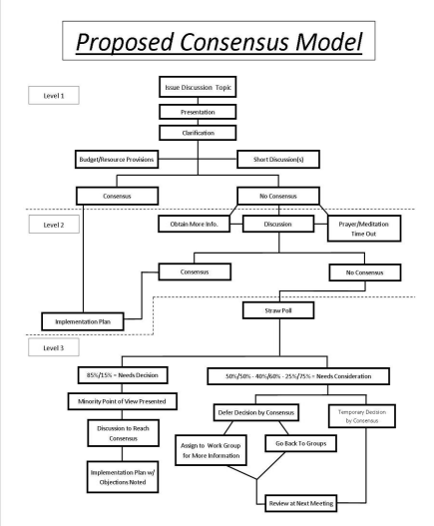Regional Consensus Model

**REGIONAL COMMITTEE**

The Regional Service Committee is a resource pool for gathering service information and experience to guide and strengthen the areas it serves. To do this, each Regional Service Committee organizes itself and performs its duties differently, according to the needs of its member Areas.

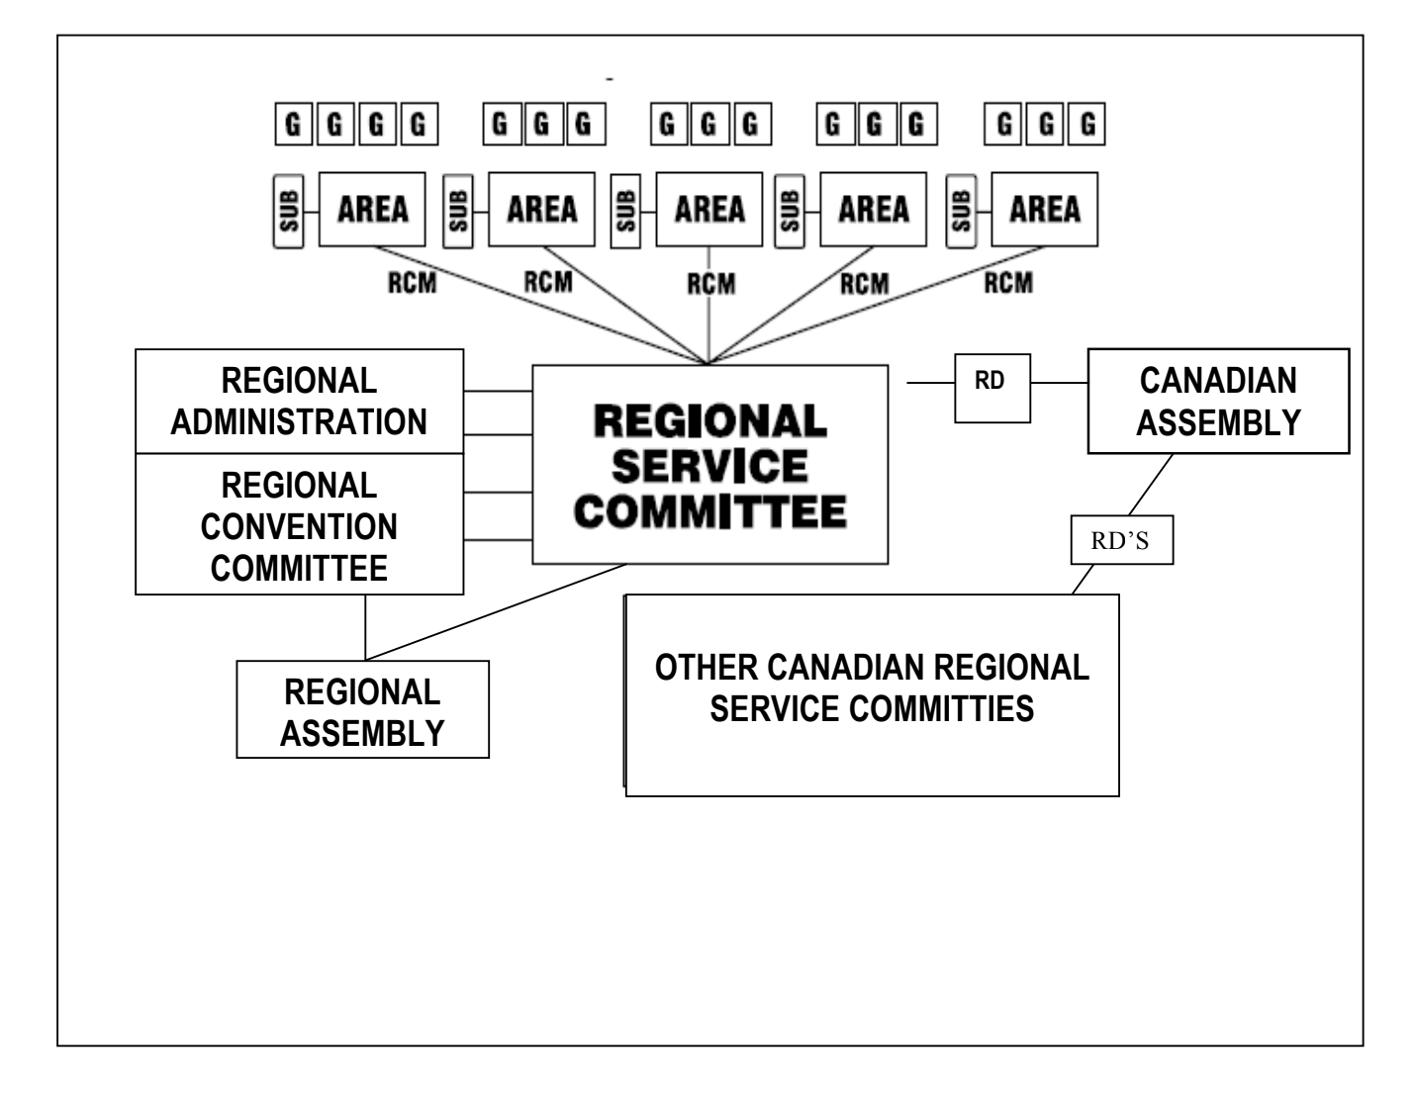

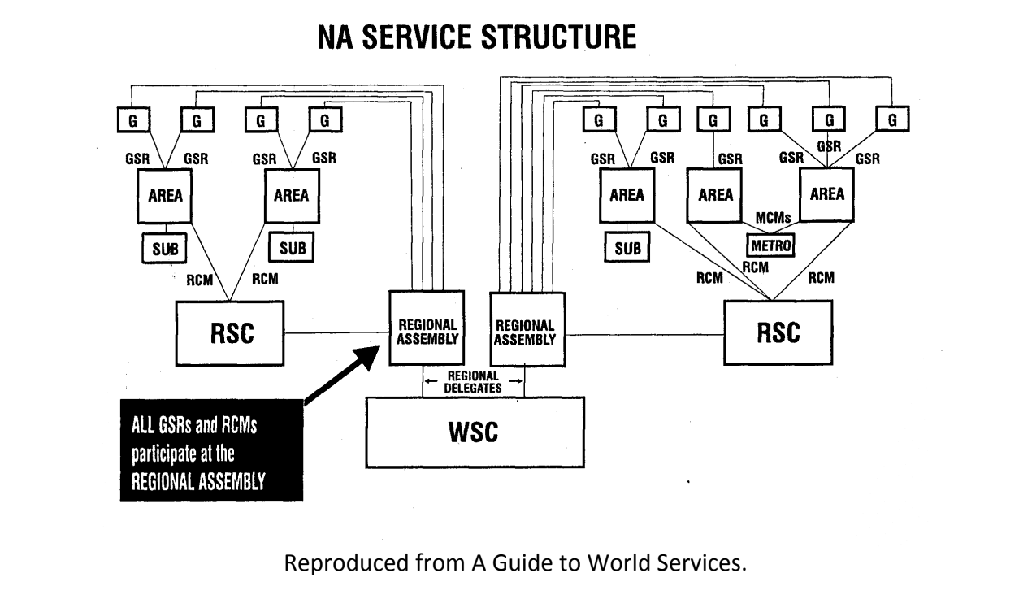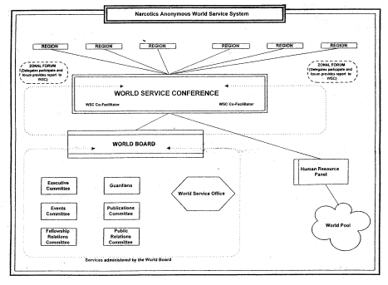

**Good Questions to Discuss with Others**

1.) Why do we have suggested clean time with positions?

2.) If you were asked to express your feeling of what a group conscience means to you, what would you say?

3.) What are your priorities at a meeting of the Regional Service Committee?

4.) What is the open forum for? And is it just for RCMs?

5.) Do you understand what discussion on a motion is for? If yes, write it out.

6.) How do your principles influence your voting?

7.) What are the reasons for abstentions? List them.

8.) What are my expectations before, during, and after an RSC meeting? List them.

9.) Are guidelines important tpo have ? Why?

10.) Do I get confused at a regional meeting? If so, how can we change that?

11.) What is the purpose of having a Regional Service Committee?

12.) What is the C.A.R. and how are you involved as a member of N.A.?

13.) What is the role of the 7th tradition in the area and N.A. as a whole? 14.) What are the responsibilities of your position? List them.

15.) Where do spiritual principles play a part in service?

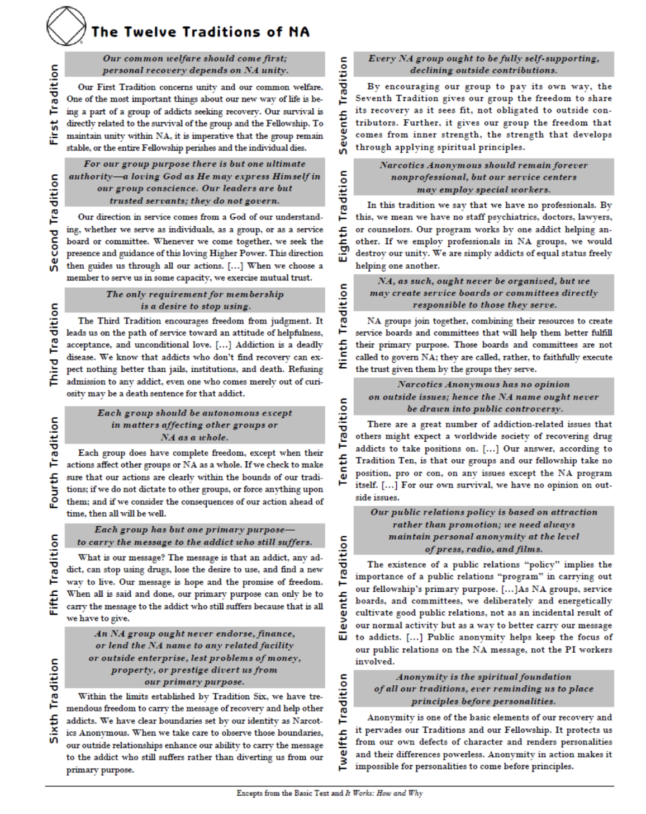

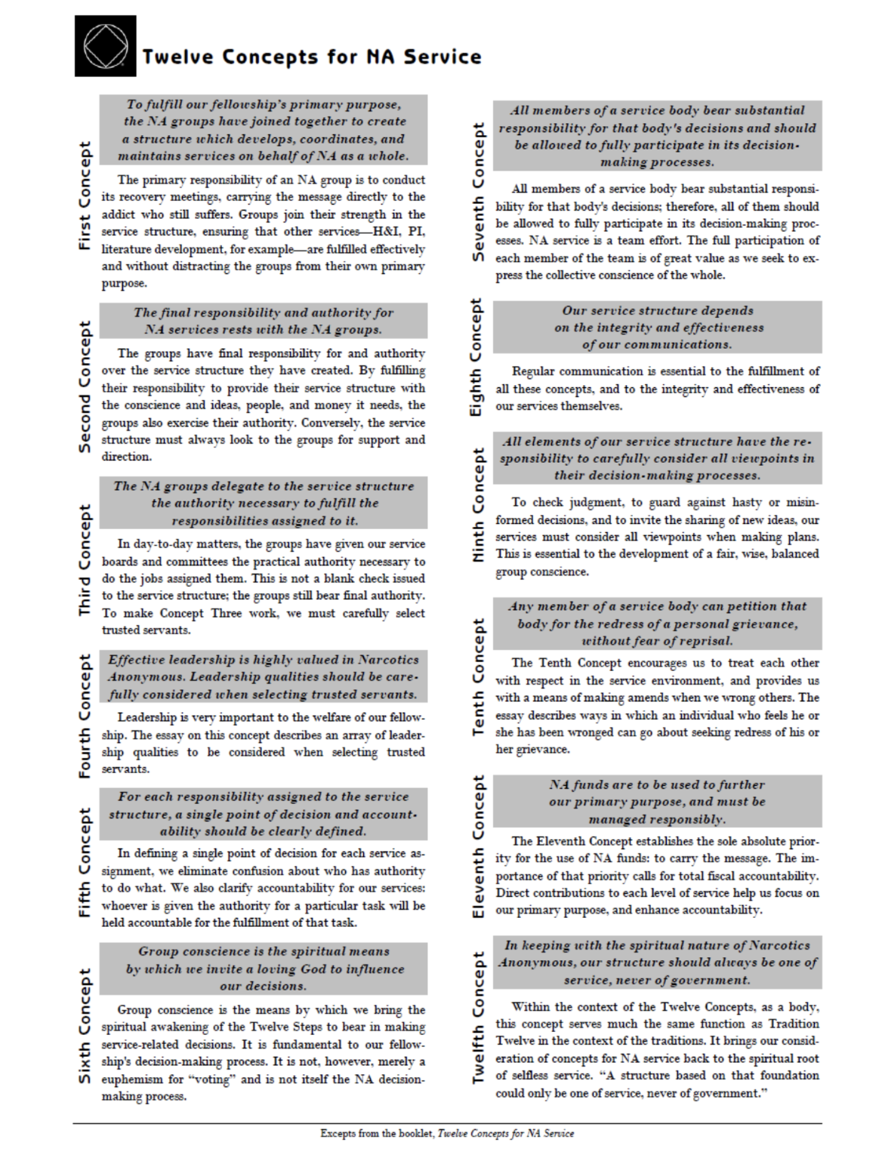

**NA Service Prayer**

NA Service Prayer**God grant us the knowledge** that we may work according to your great divine precepts.  Install in us a sense of your purpose.  Make us servants of your will and grant us a bond of selflessness, that no addict anywhere need die from the horrors of addiction.