**Our Traditions and Concepts: Recovery in Rural Communities**

**Welcome and Introduction: 5 minutes**

***Session leader’s instructions:***

*Thank the group for their time and commitment to service. Lead brief self-introductions (only if necessary). Have the group introduce themselves, stating their current service position. If the group is large or time is short then run through a ‘service position countdown’ to give an outline of the experience in the room.*

**Session Focus and Outcomes**

Our 5th Tradition states that “Each group has but one primary purpose – to carry the message to the addict who still suffers.” The purpose of this session is to explore some of the basic foundational principles of our program as they relate to the challenges of recovery in rural communities and see how we can put them into practice.

**Show map graphics of where meetings are, and where they are NOT.**

Some of the challenges include:

* Reaching out to the addict in isolated rural communities;
* Starting new meetings in rural communities where none exist;
* Public Relations – Informing professionals in rural communities about NA;
* Nurturing growth of NA groups in rural communities;

**Large Group Discussion and Prioritization: 20 minutes**

***Session leader’s instructions:*** *Ask the group to answer first:*

**When carrying the message to rural communities, what problems arise?**

**What difficulties come up?**

*Write the responses on the board. Ask the group to prioritize the list by putting a sticker by the item they think most important. This will develop the specific topics for the small group discussions.*

**Introduction to Small Group Discussion on Rural Recovery**

The source for guidance on the role we each play in rural recovery in NA comes from our Steps, Traditions and Concepts.

Any discussion of this topic must start here, and the foundation for the nurturing of recovery in rural communities in NA must start with an understanding of our Steps, Traditions and Concepts.

This session focuses on a few of our Traditions and Concepts that have much to teach us regarding the establishment of new NA groups in rural communities.

**1st Tradition**:

Our common welfare should come first; personal recovery depends on NA unity.

**5th Tradition:**

Each group has but one primary purpose – to carry the message to the addict who still suffers.

**What these Traditions teach us about recovery in isolated rural communities in NA:**

* “One of the most important things about our new way of life is being part of a group of addicts seeking recovery. Our survival is directly related to the survival of the group and the Fellowship.”
* “The therapeutic value of one addict helping another is without parallel.” “For the newcomer, this is how they found Narcotics Anonymous and learned to stay clean.”
* “The group is the most powerful vehicle we have for carrying the message.”

**How can we apply these Traditions as individual members and groups?**

* One of our most important roles as members and groups is to carry the message to those who may not have access to it.
* “We have seen members drive hundreds of miles to help support a new group...Without these actions, NA could not survive.”

**Small Group Discussion: 15 minutes**

**Discussion of Results: 15 minutes**

**Materials – Worksheet #1/ First 2 problems from board.**

***Session leader’s instructions:***

*Break attendees into small groups (aim for 5-10 per group) if they haven’t been already.*

*Assign one half of the room the 5th Tradition/1st Concept, and the other half the first 2 prioritized problems. Each group picks one Tradition/Concept or problem to brainstorm.*

Take 15minutes for each group to discuss the significance of the tradition /concept or the problems they’ve been given. Answer the same questions as the previous exercise.

**What does the tradition or concept teach us about rural recovery in NA?**

**How could we apply the tradition or concept as individual members and groups?**

**What practical solutions can you come up with?**

Come up with specific examples - **stress this point!**

***Session leader’s instructions:***

*Make sure to keep groups on task—half the allotted times per question. Announce the time a couple of minutes before they should switch from the first to the second question. Then announce the time again at the time they should be finishing.*

*At the end of the allotted time, review each tradition or concept provided. Ask groups who discussed that particular tradition or concept to report, focusing on a couple of points from their discussion.*

*Ask other groups who discussed the same tradition/concept not to repeat points already reported, but to add to the discussion with new insights. As the facilitator, add to the discussion by offering the points for each tradition or concept used in the activity.*

*Repeat the small group process with worksheet 2 and the next 2 problems.*

***Total small group discussion time: 1 hour***

**Wrap up Session - Summary: 10 minutes, if time allows.**

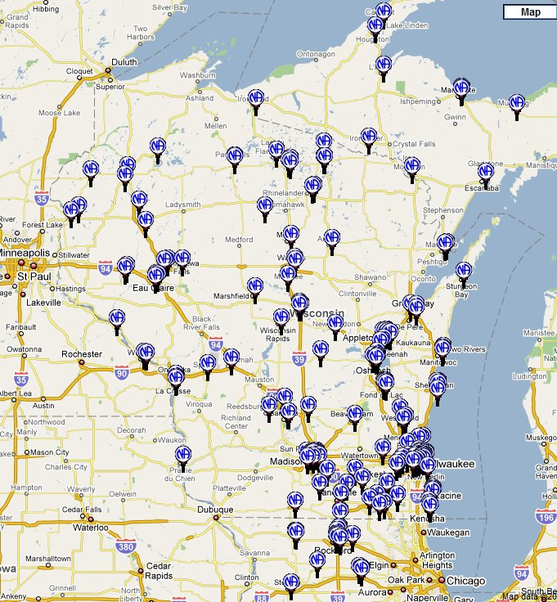

***Session leader’s instructions:***

*Encourage the group to delve further into our Traditions and Concepts to learn more about how we can more effectively carry the message in NA. Virtually all of the Traditions and Concepts have something to teach us about fulfilling our Primary Purpose.*