**Issue Discussion Topic Workshop:   
Gender Neutral and Inclusive Language in NA Literature**

**Welcome, Purpose, Background, Define Terms, NA literature 10 minutes**

**Welcome:**

Welcome everyone and introduce presenter(s)

**Purpose of workshop:**

Slide: This is a workshop about…

Put simply, this is a workshop about how we carry the message and how we can be more inclusive.

We are having this conversation to see if changes to the use of language in our literature could make our message more readily available to new and future members.

This is an opportunity to talk together, listen to one other, and build unity and understanding. We are not making decisions right now*.*

In that spirit, we want to begin by sharing a couple of members’ experiences:

Slide: quote

This first one comes from a member who says, “I identify as nonbinary and feel ‘othered’ whenever I hear ‘men and women’ in the readings or literature. Like most addicts, I just want to belong. I feel welcome in meetings, but the language makes it hard for people to use my pronouns, so while I am getting recovery NA I still feel excluded because of the language.”

Slide: quote

And here’s what another member shared, “I’m a history teacher, thanks to the education I got after I found NA. I’ve served in NA for decades and this is my home, but every time I hear ‘man’s entire history’ read during We Do Recover it makes me flinch. I sure hope one day we can change that line.”

Those are just a couple of examples. There are countless more.

There is overwhelming Fellowship support to have this conversation, facets of which have been taking place for decades.

**Background**

Slide: *CAR* survey results

The 2023 World Service Conference (WSC) had consensus to select Gender-Neutral and Inclusive Language in NA Literature as one of four Issue Discussion Topics (IDTs) for this cycle. It was prioritized as an IDT in the *Conference Agenda Report* (*CAR*) survey—chosen second of 15 options by individuals, and third by regions.

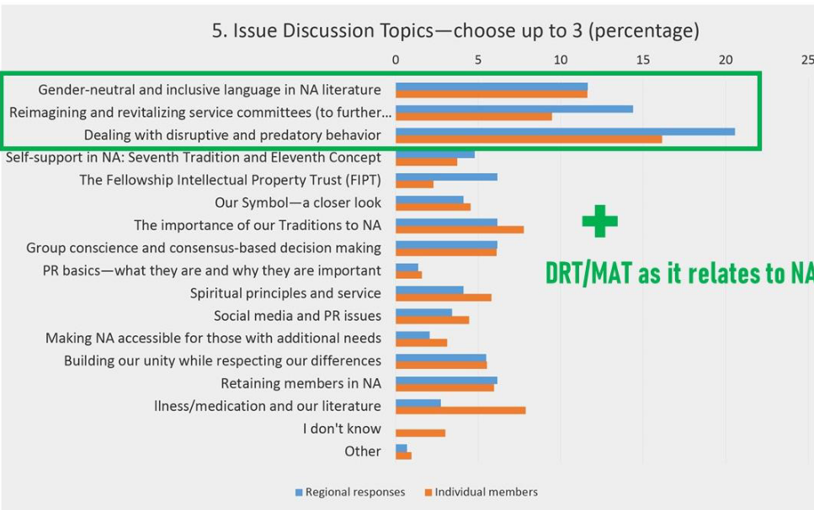

Slide: CAR Motion

The 2023 World Service Conference also passed a *CAR* motion that reads:

To direct the World Board to create a project plan for consideration at the next WSC to investigate changes and/or additional wording to NA literature from gender specific language to gender neutral and inclusive language.

Intent: This motion will give the conference and the Fellowship the ability to meaningfully discuss changes to our literature to be more inclusive of all our members.

Final Vote: 92 yes-31 no-1 abstain-1 present not voting 74% Strong Support

[The same motion appeared in the 2020 *CAR*, but was one of the items not introduced at that conference because of the limits of our first virtual WSC.]

The next World Service Conference will be held in 2026. If a project plan passes at that WSC, these conversations will help frame and inform that project.

**Define terms:**

This workshop outline was shaped by delegate input during a conference participant web meeting. Many delegates said it’s important to define terms.

Slide: So what does gender-neutral mean?

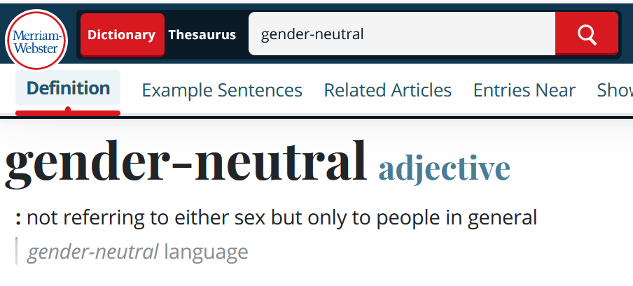

So, what does *gender-neutral* mean? In terms of the English language, it means using words that do not refer to one gender only. For example, a gender-neutral approach in English would be to use the word “people,” “addicts,” or “members” instead of the phrase “men and women.”

This IDT conversation is primarily about literature in English. NA publishes literature in 57 languages. This workshop is not intended to address the variances unique to other languages.

Slide: Revised Vision

Another example: After a 2023 *CAR* motion passed with consensus support, A Vision for NA Service now uses gender-neutral language. The words “his or her own language and culture” have been replaced with the words “their own language and culture.”

**NA literature**

Slide: Basic Text fix, pill, or drink

Many of us regard NA literature as divinely inspired, but that doesn’t mean it hasn’t changed over the years. Our Basic Text has six editions (and a revision)! Earlier versions of the text warned addicts not to take “that first fix, pill, or drink.” The phrase was revised to read “that first drug,” which is language that better reflects that “we don’t care what or how much you used.” There are many similar examples of Basic Text revisions that brought the language of the book in line with the idea that our problem is the disease of addiction, not a particular substance.

Slide: Basic Text and Living Clean example quotes

Another way that NA literature has changed over time is our more recently published books are deliberately gender-neutral. Quotes and experiences from individual members may be gendered, but the “we” parts of the texts are not. For instance, the Basic Text uses the phrase, “men and women”in sentences such as “We are **men and women** who have discovered and admitted that we are powerless over our addiction” (Chapter 2). But the phrase “men and women” doesn’t appear anywhere in *Living Clean*. Instead, *Living Clean* contains sentences such as “**We are people** who tend to learn things the hard way” (Chapter 1). The reason for this shift is to be more inclusive and to help all addicts identify.

**Experience 20 minutes**

**Full-group sharing of Experience**

We started out by hearing experience from a couple of members.

Slide: Question

* **Does anyone here have related experience they would like to share?**

Thanks everyone. We’re now going to take some time to reflect on what effect changes to our literature might have and what effect keeping our literature as it is might have.

**Small-group Discussion 40 minutes**

Slide: Questions

**Discussion**

*Break into small groups if needed. Groups should be small enough that everyone has a chance to share.*

*Select a facilitator for the discussion if in a small group and make sure everyone gets a chance to share.*

Slide: This is a discussion

Again, this is a discussion. We are not making decisions at this time. f we continue to have this discussion throughout NA, it may eventually begin to indicate a direction—what if anything the Fellowship wants to do—but for now, we are simply talking and listening to each other as members.

World Services has posted an online form at [www.na.org/survey](http://www.na.org/survey) so that the World Board can hear these conversations. Please either fill out the form individually after this workshop or select someone to take notes during discussion and fill out the form on behalf of the discussion group.

*Questions:*

* **What would be the effect if the literature were to change to a more gender-neutral way of talking about members?**
* **What would be the effect if the literature were to change to a more gender-neutral way of talking about God/Higher Power?**
* **What would be the effect if the literature didn’t change?**

**Concluding Discussion and Closing 20 minutes**

**Concluding discussion:**

*If the room broke into small groups, come back together for the concluding discussion.*

Before we close, we want to take a few minutes to share what we heard to today and how this workshop has changed our thinking.

Slide: Questions

*Questions*:

* **What was the most interesting thing you heard today?**
* **How has your understanding changed from the beginning of this workshop?**

**In closing**

Slide: Survey link, IDT page link

Don’t forget to fill out the form at [www.na.org/survey](http://www.na.org/survey)

This is one of four IDTs this cycle. The other three are:

* Dealing with disruptive and predatory behavior
* Reimagining and revitalizing service committees (to further the reach of the NA message, improve communication, provide mentorship and training, and make service more attractive and accessible, learning from our experience the past few years)
* DRT/MAT as it relates to NA

As workshop material is available, it will be posted to [www.na.org/idt](http://www.na.org/idt)